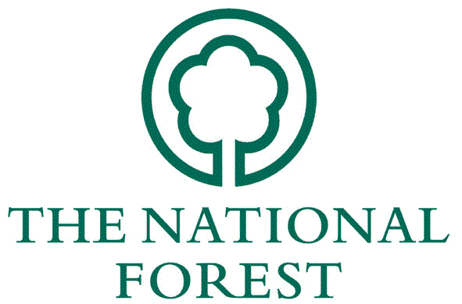
________________________________________________________________________________________

National Forest Company
Job Application Form

Job Title: Head of Land and Forestry (Reference: HOF 09/19)

Closing Date: Monday, 21st October at 5pm

If you have any difficulty completing this form, alternatives, (eg large print) can be arranged. Please contact us on 01283 551211. If you are completing the form by hand, please write clearly in black ink.
Our privacy notice for job applicants is provided at the end of this application form.

1. Personal Details
Surname |  |  | Title

Forenames
Any other names by which you have been known
Permanent Address |  |  | Address for correspondence, if different
Postcode |  |  | NI number
Daytime/Mobile Telephone Number
Email
Have you ever possessed any other nationality or citizenship? |  |  |  | Yes/No
If ‘Yes’ please give details and dates
Are you subject to immigration control? |  |  |  | Yes/No
If ‘Yes’ please specify

Yes/No

Yes/No

If ‘Yes’ please specify
If ‘Yes’ please give details and dates
Are you subject to immigration control?
Have you ever possessed any other nationality or citizenship?

2. Current Employment
Current employer's name, address and type of business | Dates:  From | To | State position held and give a brief outline of your responsibilities.
Present Salary
(show separately any bonuses or allowances received)

3. Career History - please give details of previous employment
Employer's name, address and type of business | Dates:  From | To | State position held and give a brief outline of your responsibilities. State reason for leaving.

4. Education and Qualifications
Secondary Education
Dates:  From | To | School | Educational certificates gained  (specify level and subjects with grade obtained)

Further/Higher Education
Dates:  From | To | University, college or other Institution | Full or Part-time | Courses and subjects studied | Degrees (if with honours state class and division), Diplomas and certificates obtained

Professional/other qualifications/training
Please give details of any relevant professional or other qualifications, including training courses attended, publications/papers written.

5. Assessment Criteria (Essential)
Please provide information (including examples) to demonstrate how you meet the ‘essential’ assessment criteria set out in the application pack, ie experience, knowledge, skills and personal qualities.
6. Assessment Criteria (Desirable)
Please provide information (including examples) to demonstrate how you meet the ‘desirable’ assessment criteria set out in the application pack, ie experience, knowledge, skills and personal qualities.

7. Guaranteed Interview Scheme
As part of its commitment to the Disability NFC operates a Guaranteed Interview Scheme for disabled applicants who meet the essential criteria as detailed in the job pack.

To be considered under the Guaranteed Interview Scheme, we would strongly encourage applicants to declare they have a disability and their application would be supported. Please declare below whether you have a disability, as defined by the Equality Act 2010:

☐Yes
☐No
☐Prefer not to say

8. References
Give details of two referees whom we can approach. One must be from a senior representative of your present employer. References will only be sought when a position with the Company is to be offered.
Please state the nature of the relationship between you and the referee.
Name |  | Name
Address |  | Address
Postcode |  | Postcode
Tel No |  | Tel No
Email |  | Email
Relationship |  | Relationship

9. Other Information
In order for us to monitor the effectiveness of our methods of advertising and recruitment, it would be helpful if you could tell us how you first heard about this vacancy.
National Forest website
Other |  | Please specify

10. Data Protection
Unless otherwise stated, any personal data supplied on this form, or in connection with this
application, will be used by the interview panel members for selection purposes and may be
retained for auditing.

Should you be selected, the data will form part of your personal file and could feature as part of
future selection decisions.

To progress your application we may need to disclose the information we receive from you to
others (including other public bodies, central government departments or our authorised agents).

The NFC job applicant privacy notice is available at: www.nationalforest.org/about_us/employ/jobapplicantprivacynotice.pdf

11. Personal Declaration
I declare that the information I have given in support of my application is, to the best of my
knowledge and belief, true and complete.

I understand that if it is subsequently discovered that any statement is false, misleading, or that I have withheld relevant information, my application may be disqualified or, if I have been appointed, I may be dismissed.

Signature |  | Date

You are advised to keep a copy of this form.

Please now complete the Diversity Monitoring Questionnaire

Please send your completed application and Diversity Monitoring Questionnaire to:

Angela Beech
National Forest Company
Enterprise Glade
Bath Yard
Moira
Swadlincote
Derbyshire
DE12 6BA

Or by email to: abeech@nationalforest.org

Please mark your envelope or email subject header: ‘CONFIDENTIAL - followed by the reference number for the position provided on page 1 of this form.

Please ensure you have the correct postage stamp on your application; failure to do so will cause a
delay in us receiving your application. Applications received after the closing date will not be
considered.

