Conservation volunteering opportunities in the National Forest

Forestry England volunteer Rangers

Hicks Lodge Volunteer task days:
- Every Tuesday 09:30 -12:30. Contact Chris Hart for details. Christopher.hart@forestryengland.uk
- Every first Sunday of the Month 09:30 -12:30. Contact Chris Hart for details. Christopher.hart@forestryengland.uk

Sence Valley Volunteer task days: every third Sunday of the Month 09:30- 12:30. Contact Forestry England for details. info_nationalforest@forestryengland.uk

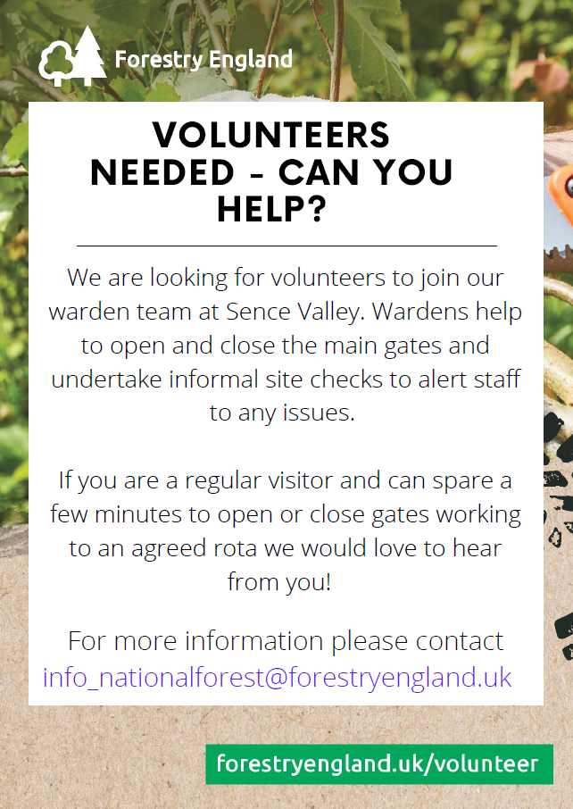

The Conservation Volunteers (TCV)
Community volunteering workdays – carry out conservation tasks such as coppicing, dry stone walling and habitat management. Weekly workdays on Tuesdays, Thursdays and Saturdays at various sites in the National Forest.
Come and join the team, learn new skills and access great training in the field of conservation and land management.

Contact Rob Driver rob.driver@tcv.org.uk
Website: https://www.tcv.org.uk/midlands/tcv-national-forest

Leicestershire County Council conservation volunteers

Various conservation groups operate around Leicestershire undertaking conservation tasks on most days of the week.
Website: https://www.leicscountryparks.org.uk/regular-groups/

Beacon Hill Country Park
Snibston Country Park
New Lount Woods
Bagworth Heath Country Park
Heart of the National Forest volunteers – workdays are on Wednesdays.

Contact Property Services Helpdesk on 0116 305 5000 or countryparks@leics.gov.uk

South Derbyshire Parklife Project

Butterfly Survey Volunteers required for our Coton Park Nature Reserve and Swadlincote Woodlands site. This is an ideal way to improve your Butterfly ID in natural surroundings. Butterfly surveys are carried out between the months of April and September on a weekly basis by volunteers on a rota.

You will be offered guidance and support to get you started and will be able to share your findings with other volunteers and Butterfly Conservation.
For further details contact the Parklife Officer cultural.services@southderbyshire.gov.uk

Coleorton & New Lount Volunteer Group

Twice weekly conservation task days throughout the year (Tuesdays and Saturdays) at Coleorton Wood and New Lount Nature Reserve.

For spring 2023, our sessions will be at:

March
Tuesday 21st Coleorton Wood
Saturday 25th Coleorton Wood
April
Tuesday 4th New Lount Reserve
Saturday 8th New Lount Reserve
Tuesday 18th Coleorton Wood
Saturday 22nd Coleorton Wood
May
Tuesday 2nd New Lount Reserve
Saturday 6th Coronation Day - no work session
Tuesday 16th Coleorton Wood
Saturday 20th Coleorton Wood
Tuesday 30th New Lount Reserve
June
Saturday 3rd New Lount Reserve
Tuesday 13th Coleorton Wood
Saturday 17th Coleorton Wood
Tuesday 27th New Lount Reserve

See website for details https://cnlvg.weebly.com/

For more information, please contact Ian McCormick, Secretary by email at coleorton11@gmail.com

Woodland Trust

We cherish, campaign for and look after the country's woods, old and new and their associated wildlife. But we can't do it without you. Volunteers have been involved at every level of the Woodland Trust's work over the last 40 years and are an integral and valued part of our team. However long you've got, whatever your interests or strengths, you can help the UK's largest woodland conservation charity to make a difference.

Key sites in the Forest are Willesley Wood (nr Moira) Queen Elizabeth Diamond Jubilee Wood (Heather) and Martinshaw Wood (Ratby). Visit our website for more details: https://www.woodlandtrust.org.uk/get-involved/volunteer-with-us/opportunities/

Woodland Trust Top Wood & Coton Wood working group – coppicing and woodland management activities in the various woods around Coton in the Elms. Contact Mark Beer, Coton Wood Ranger for information. topwoodworkinggroup@gmail.com

Wildlife Trusts

Derbyshire: Living Landscapes project, based in the Trent Valley, to look after 11 reserves including Spring Wood and Carvers Rock. The volunteer team meet regularly to undertake practical conservation, monitoring and survey work.
Contact George Bird (Living Landscapes Officer – Trent Valley)
gbird@derbyshirewt.co.uk
Mobile: 07384 253470
https://www.derbyshirewildlifetrust.org.uk/volunteer-sign

Leicestershire: various supervised groups carrying out tasks on nature reserves in the County https://www.lrwt.org.uk/get-involved/volunteer/

Staffordshire: details of volunteering opportunities on reserves and at the Trusts’ HQ https://www.staffs-wildlife.org.uk/get-involved/volunteering

Sustrans

Sustainable Transport Charity Sustrans have a very active local group here in the National Forest. Our volunteers carry out a huge range of activities, from looking after the National Cycle Network, leading rides or walks, helping to transform streets into places for people and volunteering in local schools and universities.

Email Ben Stuart, Ranger Co-ordinator for the National Forest benstuart76@gmail.com
Or visit the website to sign up https://www.sustrans.org.uk/get-involved/volunteer/

Heartwood Community Woodfuel group

Our Vision
"To become the voluntary workforce of choice for woodland management in the National Forest"
Our Mission
"The purpose of Heartwood Community Woodfuel Group is to increase the supply of sustainable wood fuel, promote a woodland culture enhancing local woodland habitat and provide broader opportunities for community engagement"
Heartwood are a fully inclusive group and have a base at Rough Park, Lount where group activities, green woodworking and charcoal making take place. We manage several woodlands in the National Forest (Foxley Wood, Linton; Nether Hall Wood, Hartshorne; Woodcote Wood, Smisby) and carry out woodland management work.

Community Woodfuel project – a membership scheme operating various task days and offering training opportunities throughout the year. Come and spend a day in the woods helping with woodland management in the National Forest, and you get to take wood home with you!

Join us – There is no formal commitment needed from you, the group is managed very informally, although health and safety in the woods is our highest priority. With around 100 members we are a growing group, so If you would like more information on how to get involved email us at chairman@heartwoodhof.org.uk

Visit our website for more details:https://www.heartwoodhof.org.uk/

Heart of the Forest Heritage Group

We are a group of volunteers who share an interest in our local heritage. We work together to tell the stories of our past; our industries; the everyday lives of families and the unique story of the landscape change across the Heart of the National Forest.

We have fortnightly drop-ins at Moira REPLAN, 2 – 4pm & 6 – 8pm. Contact us at hfheritage@gmail.com or visit the website to find out more http://www.hfheritage.org/

Moira Furnace Volunteers

If you can spare a few hours, or more contributing to the upkeep and continued success of the Furnace, whatever your skills or wishes to learn new ones - we would be pleased to welcome you to our small but dedicated team. Ages, genders and abilities are no barrier to joining our crew.

Activities include working within the grounds, helping at events, also during our open season supporting visitors in the museum and shop. Closed season work continues with maintenance of our buildings, woodland, boat and canal side.

Contact us: office@moirafurnace.org
01283 224667

National Trust (Calke Abbey)

Have you ever thought of becoming a volunteer? Well at Calke Abbey we believe that we have a volunteer role that caters just for you. Do you have free time on your hands and wish to spend it engaging with eager visitors as they visit our country house in decline? Or possibly the outdoors is more your calling, where you can spend a sunny Saturday helping in our gardens?

Find out more: https://www.nationaltrust.org.uk/support-us/volunteer

Burton Conservation Volunteers

Local wildlife and conservation group dedicated to improving the environment, promoting wildlife conservation, encouraging community awareness in and around Burton upon Trent and further afield.

Workdays – Sundays

Contact Lawrence Oates
Email: bcvflowerman@gmail.com
Website: http://www.bcv.org.uk/

Rosliston Rangers Volunteer Group

Join in with the Rosliston Rangers and help out with a wide variety of tasks to help manage the amazing habitats at Rosliston Forestry Centre. You’ll be able to try your hand at hedge laying, meadow management, coppicing and pond management. Come and join us for conservation work, site management tasks and wildlife recording.
Programme includes on-the-job training in site tasks and wildlife surveys plus some specialist training provided by local environmental experts and wildlife recorders. Based at Rosliston Forestry Centre. All tools and training given, and uniform provided too.

Task days: Tuesdays
Contact the Environmental Education Project: rosliston@southderbyshire.gov.uk
01283 535039

Whistlewood Common, Melbourne

Whistlewood is ten acres of community-owned land in Melbourne, South Derbyshire.

The site is designed along permaculture principles (a sustainable design framework) so that it will work for people, for wildlife and be a welcoming space for people of all ages and backgrounds. New additions to the site include a community garden and a Forest nursery.

We have an active volunteer programme, including a Duke of Edinburgh programme, and welcome people from all ages, backgrounds and abilities.

For more information about how to get involved, visit the website: https://www.whistlewoodcommon.org/volunteer/

Swannington Heritage Trust

Swannington Heritage Trust is an entirely volunteer run organisation maintaining 14 acres of former industrial heritage sites that are now managed as woodlands and grass heathland for the benefit of the community.

For more information about the various tasks and how to get involved, visit https://swannington-heritage.co.uk/trust/volunteer/

National Memorial Arboretum, Alrewas
For those of you who enjoy being outside, planting, pruning, doing grounds maintenance, then we recommend our working weekends. These are the first full weekend of each month and you are most welcome to come along.
For more information about our volunteer opportunities, contact our Volunteer Coordinator, Kim Riley on 01283 245 123 or email kriley@thenma.org.uk
http://www.thenma.org.uk/get-involved/volunteer/

Bradgate Park Trust

Various volunteering opportunities at Bradgate Park and Swithland Woods throughout the week. Information on the Bradgate Park website: https://www.bradgatepark.org/volunteer

Contact volunteers@bradgatepark.org or phone 0116 236 2713 ext. 26

Charnwood Conservation Volunteers

Charnwood’s many green spaces are cared for by the Ranger Service. Their role is to manage both public enjoyment and to improve their value for wildlife and eco system services.

The Ranger Service offers opportunities to become a volunteer ranger. This will involve undertaking practical conservation tasks, leading wildlife walks, organising countryside events, wildlife recording or simply patrolling our green spaces.

Charnwood Conservation Volunteers take part in a whole range of conservation events throughout the year, working on some of Charnwood's most important wildlife sites, including The Outwoods. We supply all the tools, training and help lead the tasks.

If you'd like more information on volunteering opportunities in Charnwood, visit our website: https://www.charnwood.gov.uk/pages/rangerservice
Or contact us by email: charnwood.rangerservice@idverde.co.uk

Transforming the Trent Valley partnership

Transforming the Trent Valley is a partnership project of 18 organisations working together to restore and enhance the natural and cultural heritage of the Trent Valley, with Staffordshire Wildlife Trust at the helm. It has funding until April 2024.
There are lots of volunteering opportunities to get involved in, from community initiatives to wildlife, history and access projects. https://www.thetrentvalley.org.uk/volunteer.php
The project area reaches from Rugeley to Shardlow, along the Trent Valley. It also takes in the Dove valley from Rocester to Egginton, and the Tame Valley from Hopwas to Alrewas. https://www.thetrentvalley.org.uk/area.php
Follow Transforming the Trent Valley on Twitter at @TheTrentValley, on Instagram at TheTrentValley or like our Facebook page.

Sinai Park House Trust

Sinai Park House is a hilltop site (near Shobnall, Burton upon Trent) overlooking the Trent Valley, used as a sacred meeting place and a strategic outpost from earliest times. The Paget family reinvented the timber-framed shooting lodge as a stylish Elizabethan manor house with a 13th-century moat, and a host of extensions and refinements have been carried out every century since, all in the Medieval and Tudor style.

Now developing as a heritage attraction with education visits, the Trust are looking for volunteers to help with events and conservation work.

Email: kate@sinaiparkhouse.co.uk
https://sinaiparkhouse.co.uk/

Ashby Canal Association

We are a charity looking after the Ashby Canal, and working to restore the canal back to water northwards to Measham. We welcome any kind of volunteer help.

During the autumn, winter and spring months we hold regular work parties – usually on the third Sunday of each month. We usually start around 10am. Our regular meeting place is Snarestone Wharf, off Quarry Lane, Snarestone, DE12 7DD, though sometimes we work elsewhere along the canal.

If strenuous physical work is not for you, there are many less active support and administrative roles you might wish to consider, such as helping with our publicity, assisting with our archive of documents and photographs, maintaining contact with our magazine advertisers, liaising with schools, helping at events, and so on.

You can contact us at arran.jenkins@ashbycanal.org.uk We would love to hear from you.

Website: http://www.ashbycanal.org.uk/volunteering/

Severn Trent volunteer Rangers

Work alongside skilled & experienced rangers to help deliver a wide range of practical conservation tasks across several Derbyshire reservoirs. We undertake a variety of projects including coppicing, hedge laying, fence & footpath repairs, pond restoration, survey skills & more. Build new skills, gain training & experience or simply socialise & get outside. If you think we might suit you please get in touch & we can chat about what your requirements are to see if we have an opportunity for you. We provide H&S instruction, supervision & all tools & equipment & a full uniform along with organised social events. We currently work on a Tuesday but can be flexible on days. Would suit those of a practical nature, who are physically fit & willing to work outdoors in all weathers. No previous experience necessary, but you must be able to professionally represent the organisation. Please contact the site team staunton.foremark@severntrent.co.uk or 01332 865081.

Swadlincote in Bloom
Are you bored with looking at four walls?
Do you really want to go and do something interesting, healthy and good fun but are scared to travel far?
Come and help Swad In Bloom make a difference in Swadlincote!
We have a great group of volunteers but we could do so much more if we had more active volunteers. We are looking for volunteers to help on our stalls, help with our gardening projects, help with fundraising and so many more areas. We really want to make Swad bloom and we would love you to join us.
At the moment we have our Community Garden at the rear of South Derbyshire CVS, monthly stalls on the Delph, a community crocheted tree which will be displayed in Morrisons foyer and many other projects waiting for volunteers.
It can be an hour or two once a month, a regular weekly tidy up in the CVS garden or helping by fundraising. We will never let volunteers work alone on any project and can guide you in what needs doing.
We would love to meet more of you so check out our facebook page @Swad_in_Bloom or email treasurer@swadinbloom.org if you can help.

The National Forest Way volunteer Rangers

National Forest Way volunteer Rangers – join our team of footpath guardians, and carry out self-led audits and inspections of the National Forest Way and other promoted walking routes.
Occasional task days are held (usually Thursdays) to carry out maintenance and repair work.
Contact enquiries@nationalforest.org
Website https://www.nationalforest.org/get-involved/volunteering-opportunities

Overseal Footpaths Group

Local footpaths group operating in and around Overseal village to help look after and maintain the Parish footpaths. The group runs weekly health walks, and occasional task days – Wednesdays.
Contact Dot Morson dorothymorson@btinternet.com

Melbourne Footpaths Group

Local footpaths group operating in and around Melbourne village to help look after and maintain the Parish footpaths. There are regular guided walks and occasional task days.
Details on website https://melbournefootpathsgroup.wordpress.com or contact through Facebook page www.facebook.com/MelbourneFootpathsGroup

Branston Friends Group

An active group of volunteers living in Branston Parish who help keep the footpaths clear, the streets tidy and the planting beds in bloom. The group runs occasional task days and guided walks. Contact Parish Clerk for details: clerkbranstonparishcouncil@gmail.com

