The National Forest Farming & Forestry Grant

New Funding for Innovation
Farmers are facing the challenge of combating climate change, biodiversity loss and food security, while also trying to maintain successful and sustainable businesses. A challenge made even greater by exceptional inflation, soring input costs, and labour challenges. As nature-friendly sustainable food production is crucial for all our futures, the National Forest Company would like to help.
We are adapting our grants and support to help farmers increase their businesses climate resilience, reach net-zero, and support the production of food by funding greater integration of trees into farming. That’s why we’re seeking expressions of interest for areas of land to be brought into a combination of agroforestry, woodland and wildlife habitats, to demonstrate transformation at scale, without removing land from production.
The Farming & Forestry Grant is piloting a new approach to tree planting that creates a true partnership between the landowner and the National Forest Company. It’s not just about planting trees, it’s about helping farm businesses survive, grow and diversify. The land can be split across more than one ownership but must form a single contiguous block, and would ideally be over 25 hectares (62 acres). The project must deliver benefits for the National Forest. The competitive tender process encourages applicants to be bold and innovative in their approach to integrating trees into their farms, and gives them the opportunity to set out the ongoing support they need for this long-term decision.
The total grant fund is one million pounds and will fund a range of activities including the planting of woodland and creation of new wildlife habitats alongside greater integration of trees and productive farming through agroforestry. Agroforestry can include traditional practices such as heritage orchard grazing, hedgerows and wood pasture, as well as innovative systems such as growing alleys of productive trees through arable crops and forest farming.

What will we fund?

Silvopastoral agroforestry
Silvopasture is the combination of trees and livestock, usually in the form of grazed wood pasture. By planting lines, scattered or clumps of trees across grazing pasture, farmers can benefit from an extended grazing season, increased soil health, the reduction of the effects of wind exposure and heat stress on livestock, supplementing livestock diet, and a reduced incidence of pests and diseases.

Silvoarable agroforestry
Integrating trees in arable or horticultural systems can reduce wind speed, crop evapotranspiration and soil erosion. In organic systems, the inclusion of trees may also provide benefits for pest and disease control. Silvoarable agroforestry also offers opportunities to diversify farm income with tree products such as timber, woodfuel, fruits and nuts.

Woodlands
Planting new woodlands to enhance local biodiversity, add to the local landscape, and provide opportunities to diversify income. Many farmers in the National Forest have used tree planting to frame new enterprise such as camp sites, fishing lakes, cafes, shops, or liveries. They can also provide screening and a buffer to sound from nearby roads or other operations and help clean the air, all whilst producing timber. Woodlands can grow food and protect crops and livestock.

Other non-wooded wildlife habitats
Alongside woodlands, the Farming & Forestry Grant will also fund the creation of wildlife-friendly habitats such as wildflower grasslands, beetle banks, ponds and reedbeds. Increasing habitats for predator insects can help protect crops while reducing chemical usage.

Boundary features
Creating new boundary features such as hedgerows, hedgerow trees, shelterbelts and riparian buffer strips can have multiple benefits to farmers. When designed and positioned carefully, they can reduce wind leading to increased crop growth rates and quality, protection from windblown soil, moisture management and soil protection. Higher air and soil temperatures in the lee of a windbreak or hedge can extend the crop growing season. For livestock, reduced wind speeds and chill factors can increase live weight gain and milk production, reduce feed costs and young stock mortality. Boundary features can also reduce soil erosion from water, by reducing soil compaction and increasing infiltration rates and reducing overland flow of water. They also protect nearby watercourses by reducing sediment and pollution run-off, and reducing flooding by increasing soil water storage ability.
We would particularly welcome the submission of large schemes which deliver expansive new areas of tree planting and make a significant contribution towards NFC’s goals.
See the accompanying information for links to resources, examples, and inspiration.
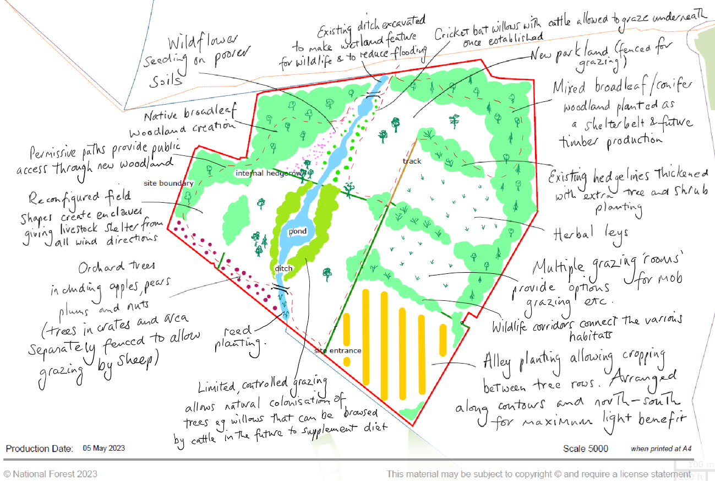
Example design sketch.

The Application Process
The application process is designed to be as simple as possible for the landowner and is split into two main stages. Our officers will be on hand to provide advice during the first stage and, for those applications that reach the second stage, specialist land agents will be funded to support with the detailed design, costing and application.

Stage 1 - Expression of Interest
The first step of the process is a simple Expression of Interest (EoI) setting out who you are, how much land you’d like to enter into the pilot, what you’re looking to do, and what it will do for your business. The final part of the EoI is what you think the project will offer to the National Forest.
Our support includes visiting your farm and providing advice on the various options you have. We're here to help you make informed decisions about the mix of land uses and the potential benefits that come with them.
EoIs will be reviewed by a panel of NFC Trustees and external advisors to determine which schemes will be taken forward to Stage 2. The decision will be made on the basis of the potential outcomes that the projects could deliver for the environment, the local economy and nearby communities.

Stage 2 - Tender
Schemes chosen to proceed to Stage 2 will be matched with a specialist land agent (if you do not already work with one). The agent will be funded by the NFC to work with you to design the scheme, work out the costs of establishment and maintenance, and produce the final application. The application will take the form of a competitive tender, where you set out what you propose to do, how much it will cost and how it presents value for money. The pilot is being funded through Defra’s Nature for Climate Fund and the NFC will need to be able to demonstrate how the successful project is providing public benefits, including environmental interventions, in return for public funds.
The Stage 2 tenders will be scored against a published set of criteria that will be shared with you at the start of the process. Each scored project will then be presented to an expert panel, which will make the final decision as to which scheme(s) will be awarded the funding.
The NFC will work with unsuccessful applicants to see if elements of their proposals can be brought to life through other available grant mechanisms.

Stage 3 – Delivery
Successful projects will be secured by a 25-year contract and fully funded by the NFC. The initial establishment will be delivered by the applicant’s agent, with 100% of the establishment funds paid to the applicant at the end of the first year’s delivery.
Payment of maintenance funds will depend on the applicant’s proposed claim timetable. Regular site visits will support the applicant and monitor the project.

Expression of Interest

Why are we asking you to complete an EoI?
We recognise the amount of work that goes into applying for funding and planning a project. The EoI stage helps us to filter out any projects which are unlikely to receive this funding and saves you time working on a full application unnecessarily. If this is the case, we may be able to support you through our other grants.

About you
Full Name:
Address:
Postcode:
Telephone:
Email:
Are you the owner of the land or a tenant?
Does the project cover more than one land ownership? | Provide details.
Total land ownership of partners in hectares:
Are all parties registered for VAT?

About the site
Farm Name:
Farm Address:
Grid Reference:
Project size in hectares:
Rural Land Register Number:
Single Business Identifier Number:
Has the land received funding from an agri-environment scheme? | Provide details.
Please attach a concept sketch of the project (see example above).
Please use the boxes provided, additional paper or compose digitally.
Describe the current usage of the land.

Describe what you will do as part of the project.

What will the project do for your business?

Which of our outcomes do you think your project could deliver against?
We don’t expect projects to deliver against every outcome listed below, we would sooner they delivered fewer outcomes to a high standard. Please note that we consider some of the outcomes to be more important than others, so we have labelled each as either Essential, High, Medium or Low. In scoring the Expressions of Interest, they will be compared against each other and scored based on how well they could deliver these outcomes.
- Create
  - ☐ Increase forest cover through woodland, parkland, boundary and in-field tree planting, and through controlled grazing wood pasture. Essential.
  - ☐ Project scale. High.
  - ☐ Increase abundance of priority habitats and species. High.
- Manage
  - ☐ Manage land for the enhancement of priority habitats and species, an increase in biodiversity and the sequestration of carbon. Medium.
  - ☐ Manage trees and woodlands to promote health and sustainability. Medium.
  - ☐ Manage and enhance cultural heritage. Low.
- Inspire
  - ☐ Showcase innovation and share knowledge within farming and forestry sectors. Essential.
  - ☐ Engage with educational establishments to deliver farming, forestry and land management educational opportunities. Low.
  - ☐ Help deliver 100% of primary schools undertaking regular outdoor learning. Low.
- Engage
  - ☐ Create and manage public access. High.
  - ☐ Engage with local communities to develop support and understanding of farming and landscape change. High.
  - ☐ Signage and interpretation. Medium.
  - ☐Support the growth of volunteer groups through volunteering opportunities for woodland and habitat monitoring and management. Low.
  - ☐ Work with partners to research agroforestry systems and share the findings. Essential.
- Grow
  - ☐ Support the farming and forestry sectors through showcasing, creating and maintaining employment. Medium.
  - ☐ Support the farming and forestry sectors by creating sustainable products. High.
  - ☐ Support the farming and forestry sectors by testing income generation through the sale of natural services such as carbon sequestration and Biodiversity Net Gain. High.
  - ☐ Support the National Forest in developing as a forest inspired sustainable visitor destination. Low.
How will your project do this?

Carrying out your project.
Have you received any specialist advice on your idea? If so, who provided this advice?

We would like to see the majority of the capital works delivered within the 2024/25 financial year (e.g. by 31 March 2025). Might this be achievable with your current commitments?

Is there anything else you’d like to tell us?

