Resources, Examples & Inspiration
Further information on the benefits of agroforestry can be found in the Soil Association’s Agroforestry Handbook: https://www.soilassociation.org/farmers-growers/low-input-farming-advice/agroforestry-on-your-farm/download-the-agroforestry-handbook/.
Allerton Trust’s Nature Based Solutions: https://www.allertontrust.org.uk/wp-content/uploads/2022/01/Natured-Based-Solutions-to-Habitat-and-Crop-Management.pdf
Woodland Trust’s Agroforestry Benefits Nature, Climate and Farming: https://www.woodlandtrust.org.uk/plant-trees/agroforestry-benefits/
Forestry Commission’s Integrating Trees, Woodlands and Forestry into Farming Practice: https://www.youtube.com/watch?v=-UPL9Of32v4
Soil Association’s Agroforestry in England – Benefits, Barriers & Opportunities: https://www.soilassociation.org/media/15756/agroforestry-in-england_soilassociation_june18.pdf
Agroforestry Research Trust: https://www.agroforestry.co.uk/
Sustainable Food Trust: https://sustainablefoodtrust.org/news-views/agroforestry-an-opportunity-for-sustainability/
The Promise of Agroforestry: Lessons from the Field: https://landworkersalliance.org.uk/wp-content/uploads/2018/10/Promise_of_agroforestry_web_pageview.pdf
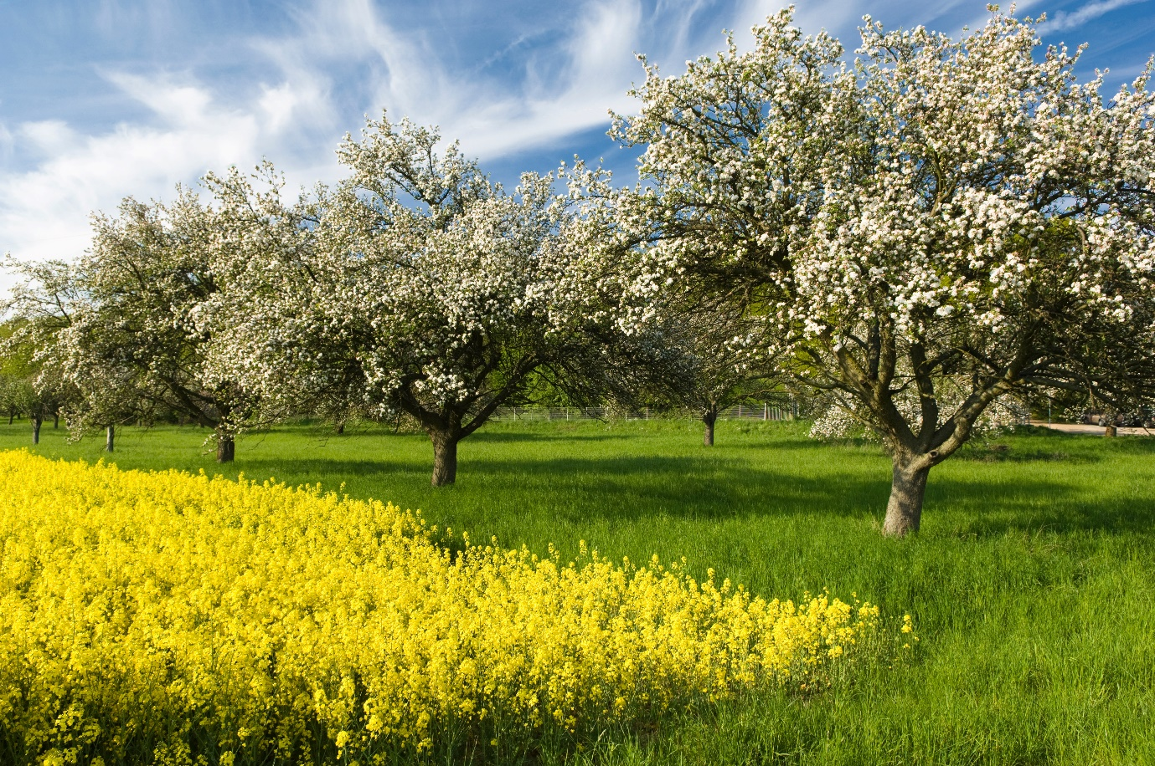
Integrating fruit trees and arable crops.
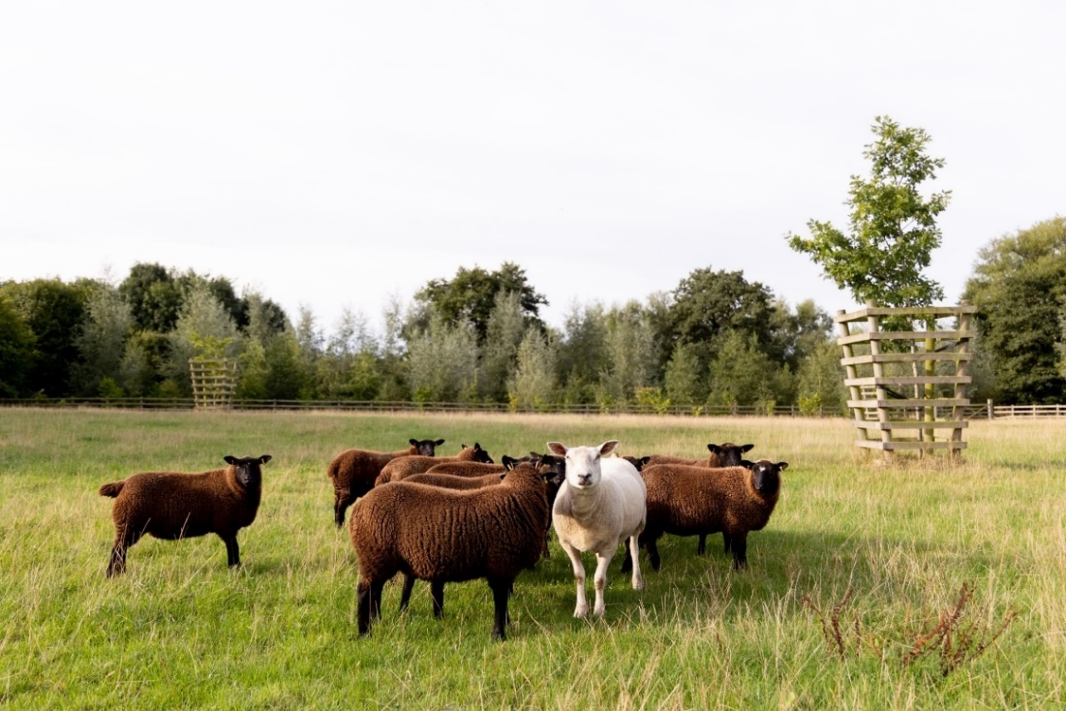
Sheep grazing silvopasture with shelterbelts in the National Forest. Credit Darren Cresswell Photography.
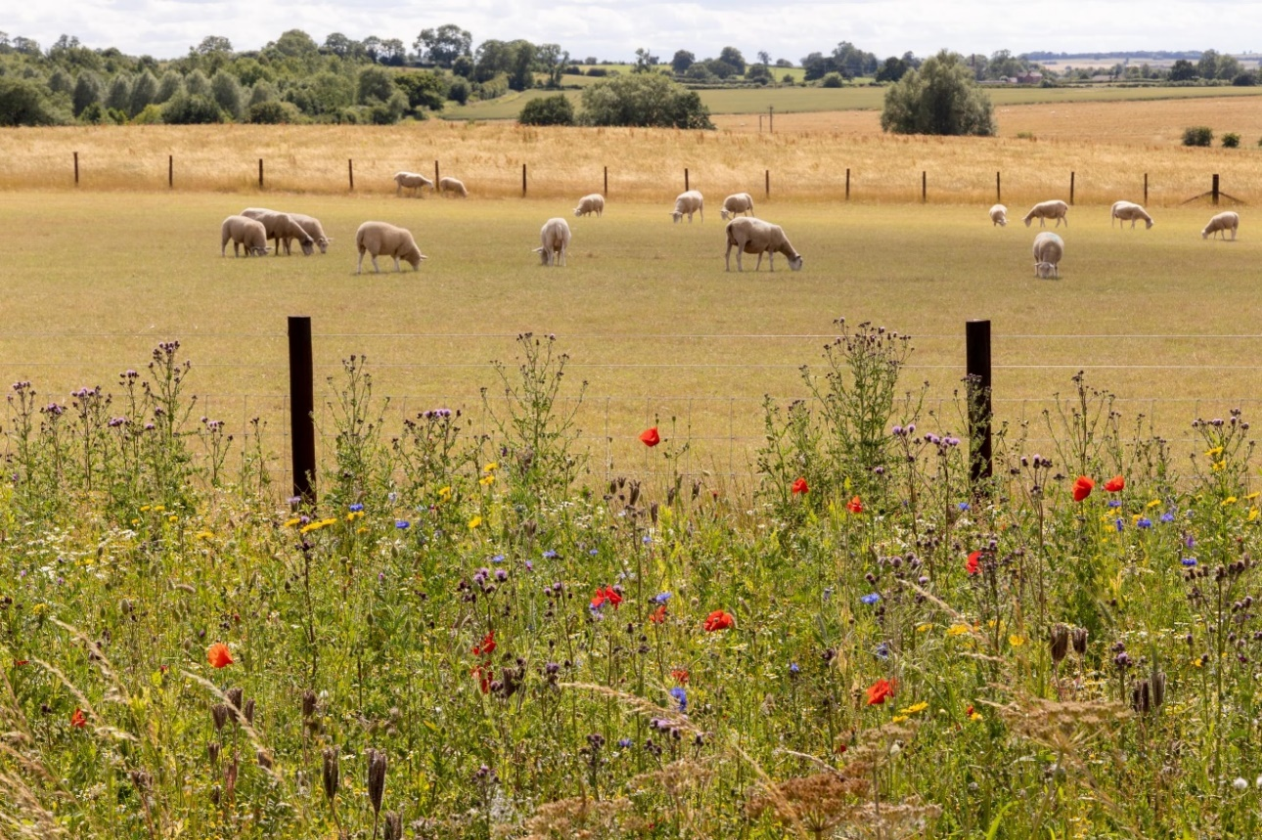
Wildflower grasslands border grazed fields and young woodland at Minorca Woods in the National Forest. Credit Darren Cresswell Photography.
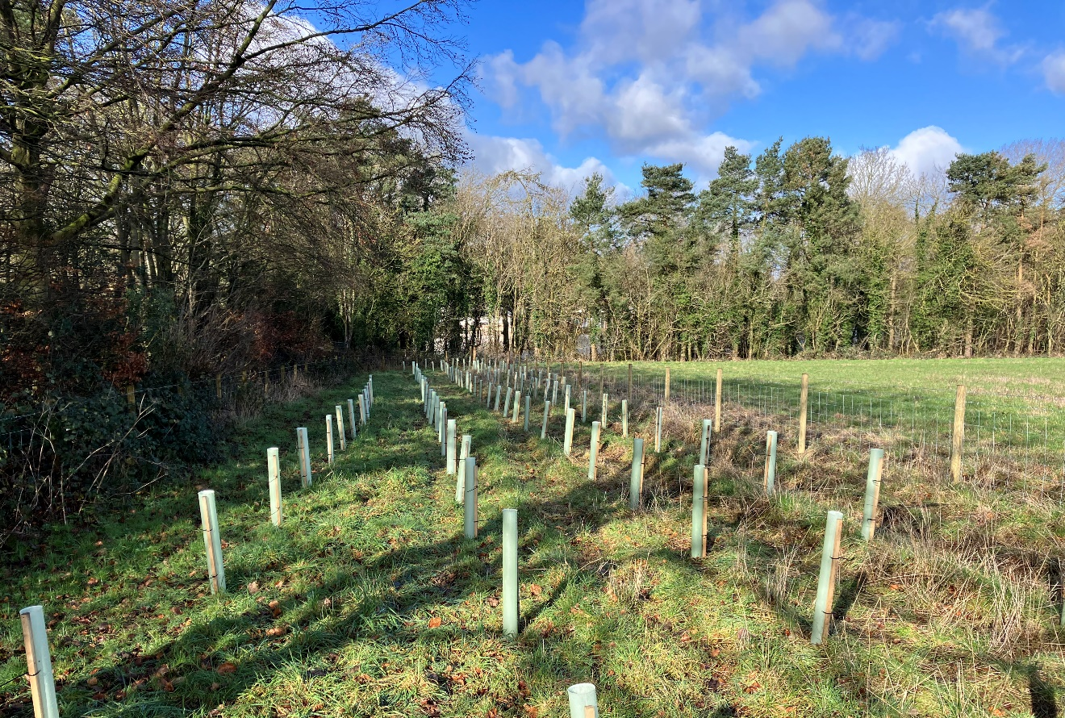
Buffer strip planting in the National Forest. Credit Rob Cleaver.
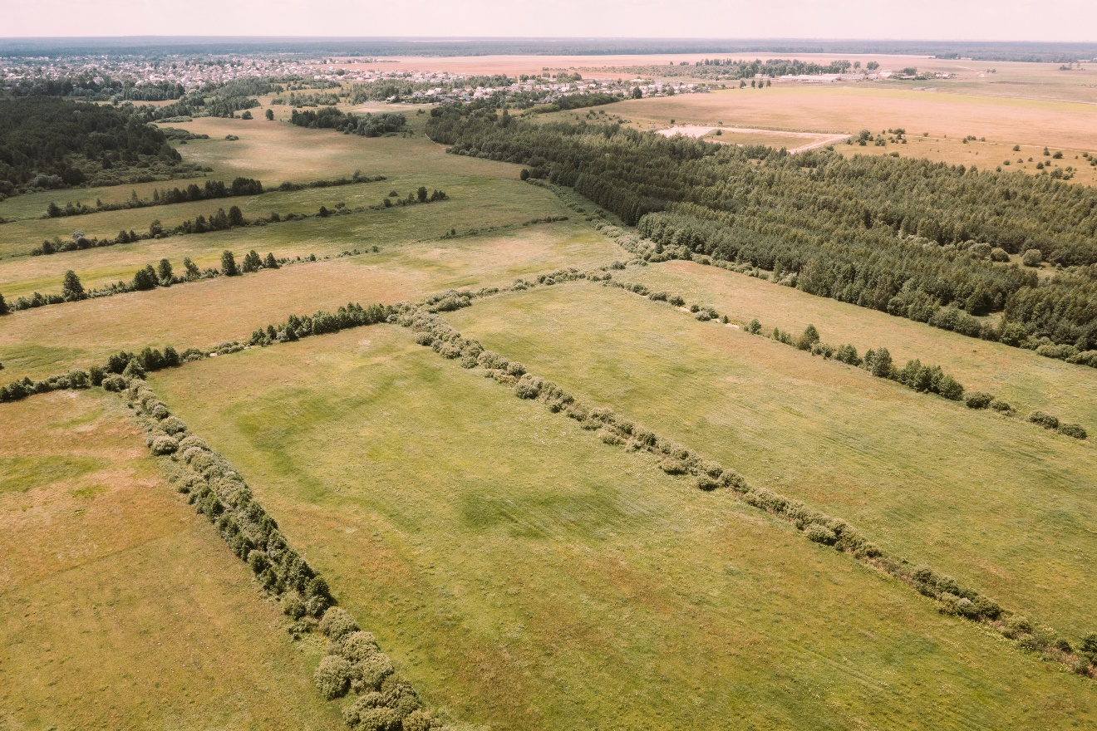
Boundary features such as hedgerows and field boundary used to create shelter.
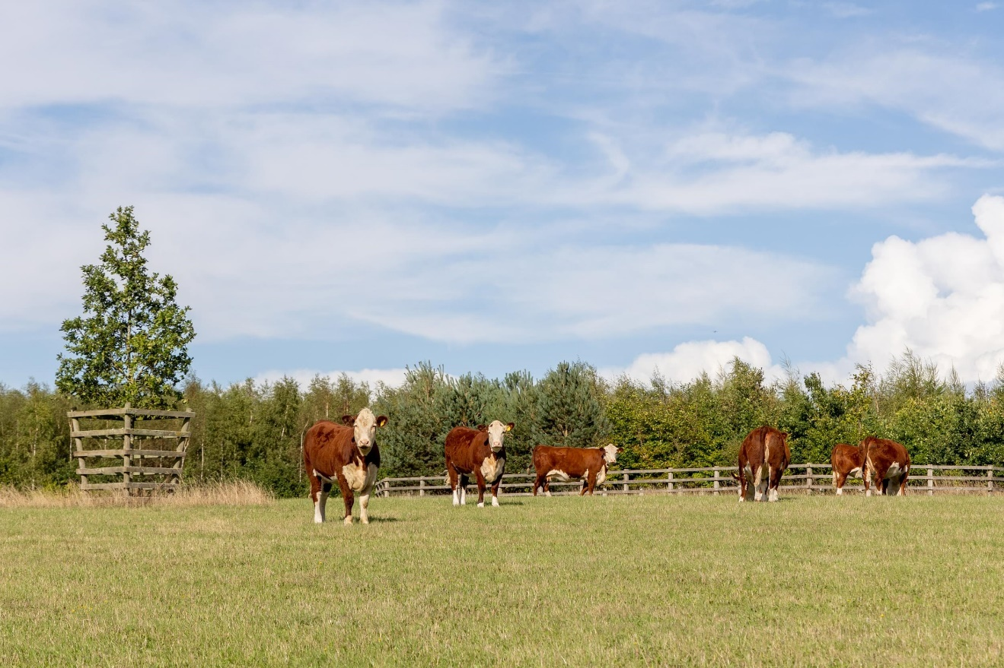
Cattle grazing in silvopasture with shelterbelts in the National Forest. Credit Darren Cresswell Photography.

