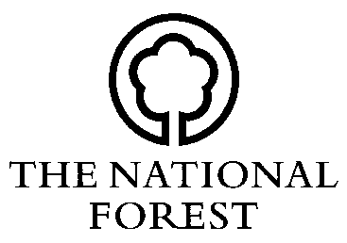
NATIONAL FOREST SCHEMES

BACS DETAILS FORM (NFC BACS)

Contact Details

Title

Forename

Surname

Address

Postcode

Email

Scheme Reference

Telephone Number

Bank Details

Bank Name

Account Name

Account No.

Sort Code

DECLARATION I am *the owner/the lessee/the agent, named in the approved Contract as numbered above.*delete as appropriate
 | Signed | Position | Date

To be returned to: National Forest Company, Bath Yard, Moira, Swadlincote, Derbyshire, DE12 6BA.

Tel: 01283 551211 Fax: 01283 552844 Web: www.nationalforest.org

