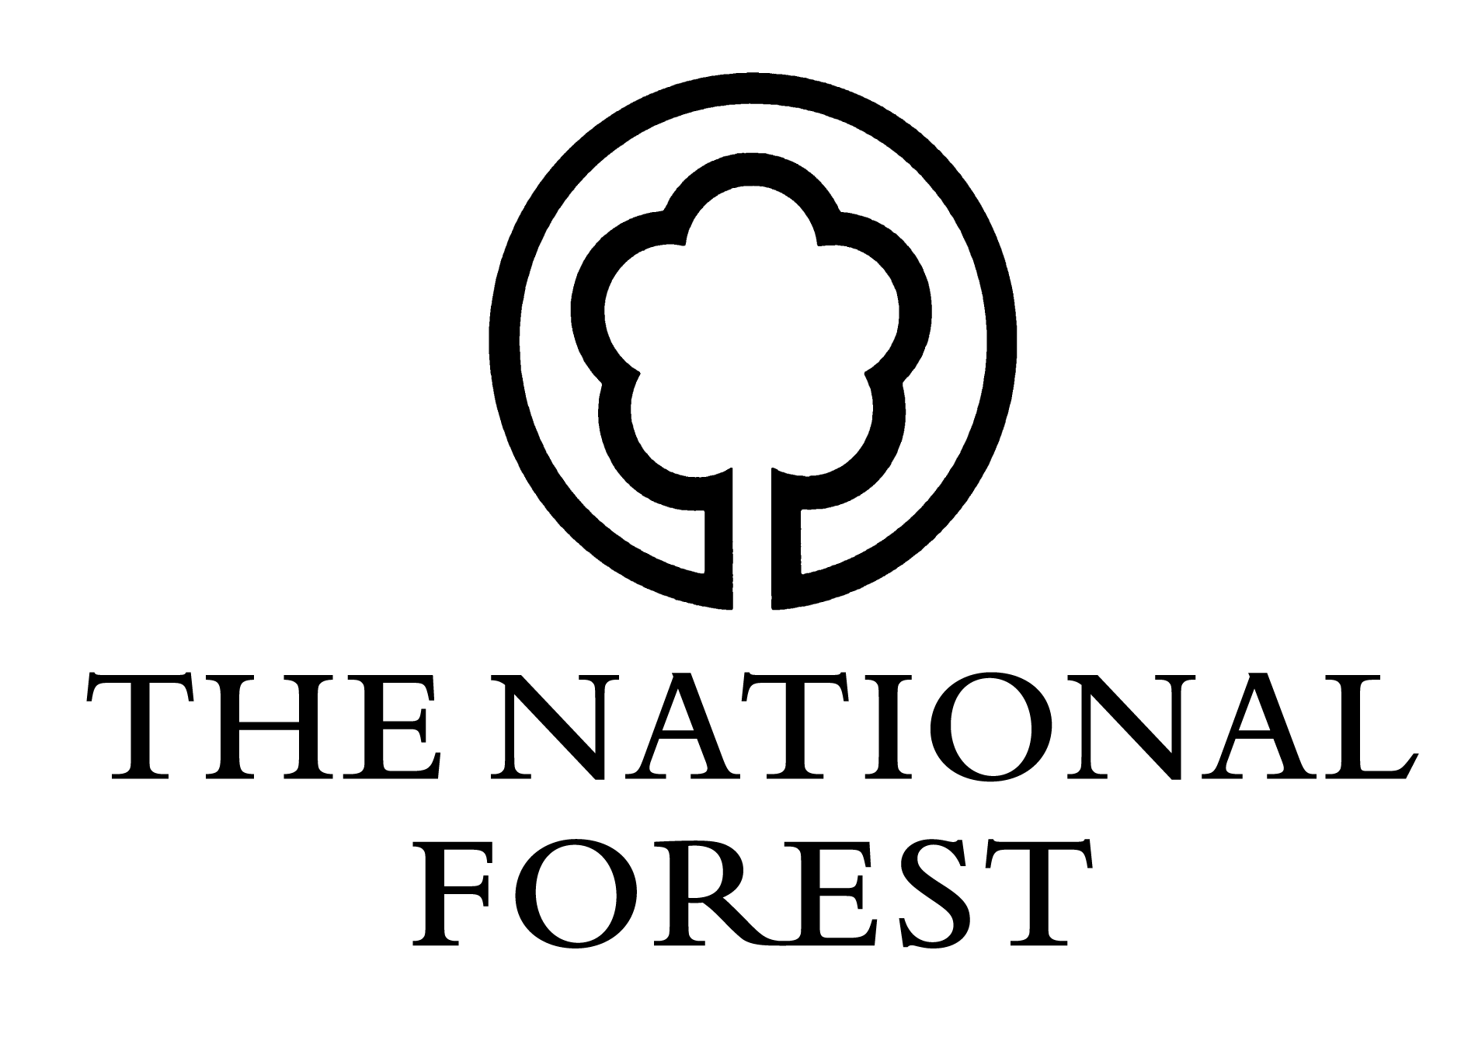
Changing Landscapes Scheme
BACS details (NFCBACS)
NOTE: This section must be completed for all grants where payment by BACS transfer has been requested. If this information is not provided, payment will be made by cheque.
Contact Details:
Full name:
Address:
Postcode:
Phone number:
Email:
Scheme reference:
Bank Details:
Bank Name:
Account Name:
Account No:
Sort Code:
Declaration:
I am the owner/the lessee/the agent* named in the approved contract as numbered above (delete as appropriate)
Name: _______________________________________
Position: _______________________________________
Signed: _______________________________________
Date: ___/___/_____
Please return to: National Forest Company, Enterprise Glade, Bath Yard, Moira, Swadlincote, Derbyshire DE12 6BA. Telephone: 01283 551211 Email: grants@nationalforest.org

