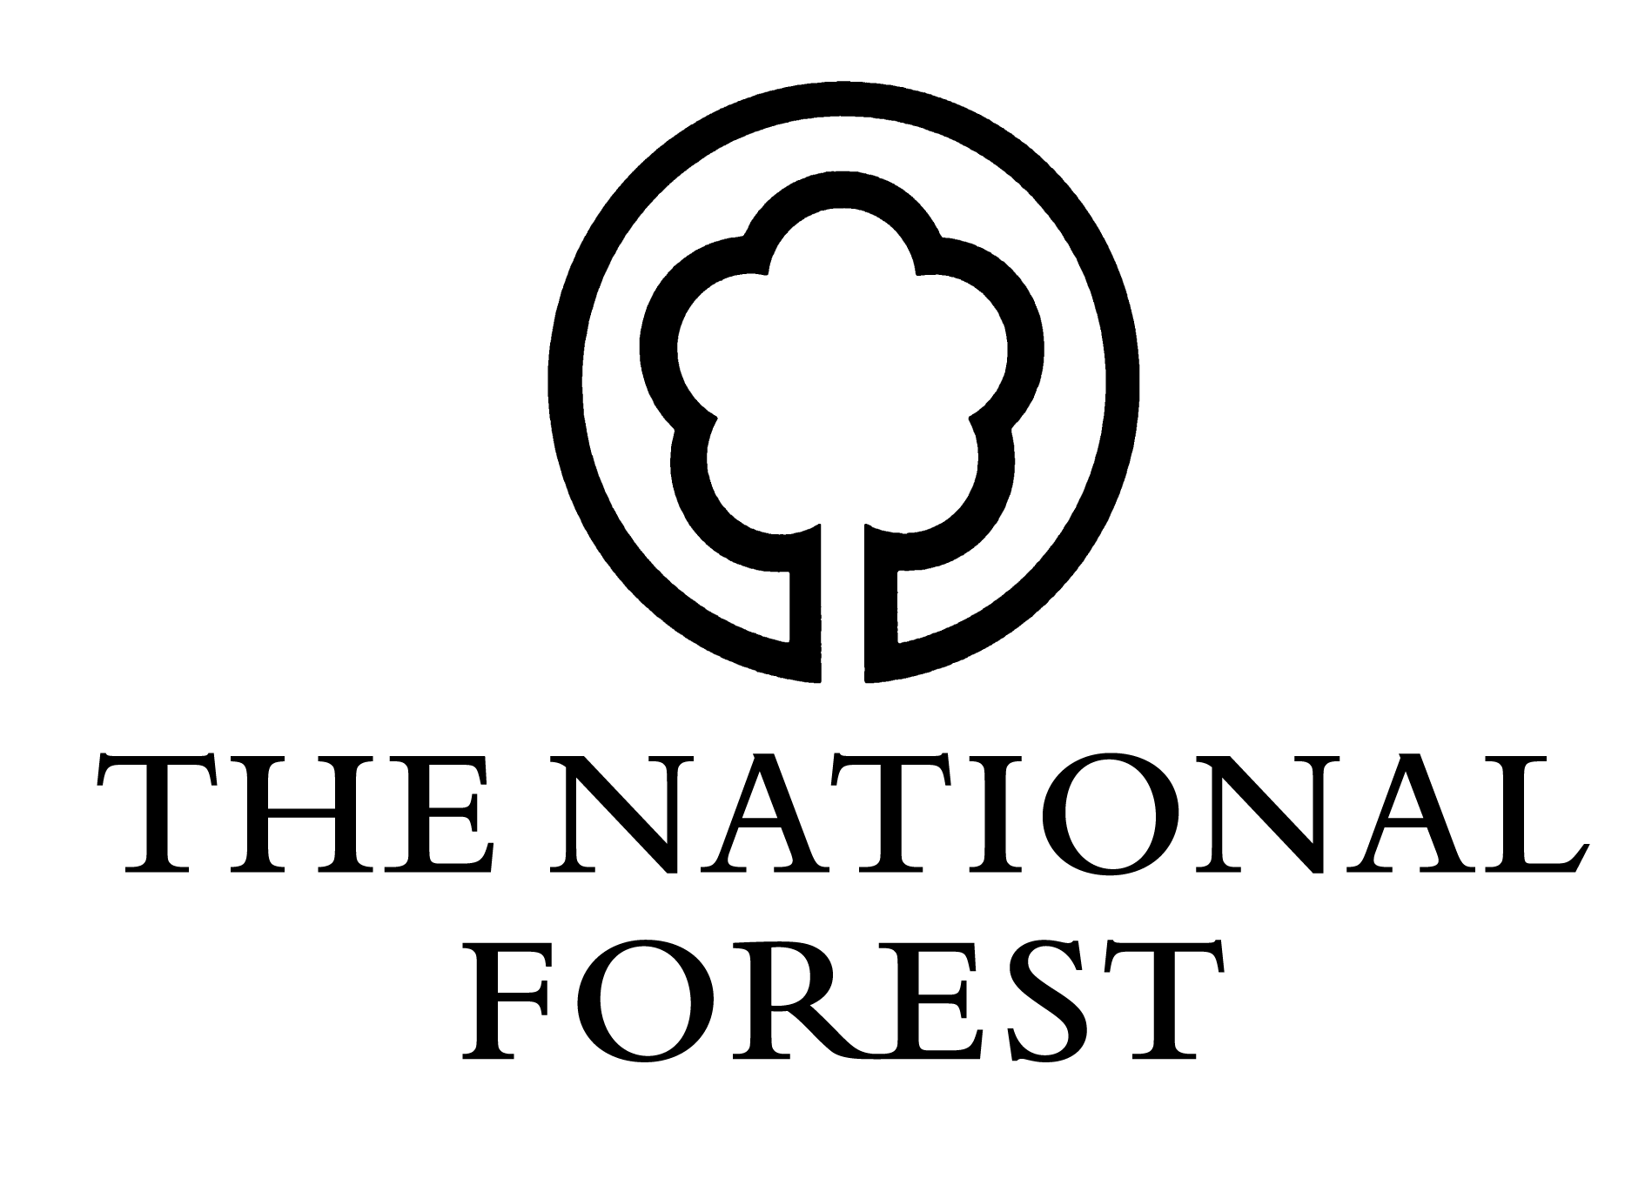
Changing Landscapes Scheme

Claim Form (NFCLS2)
Please return to: National Forest Company, Enterprise Glade, Bath Yard, Moira, Swadlincote, Derbyshire DE12 6BA. Telephone: 01283 551211 Email: grants@nationalforest.org

Section 1: Personal Details
Full name:
Address:
Postcode:
Phone number:
Email:
Payment preferred by BACS / Cheque (please delete as appropriate)
Name on cheque / account:
If payment by BACS is requested, please complete NFCBACS

Section 2: Scheme Details
CLS Reference:
Grid Reference:
Site Name:

Section 3: Declaration
I am the owner/the lessee/the agent named in the approved Contract as numbered above (delete as appropriate).
I certify that:
- there has been no change of circumstances within the Contract.
- planting or the work necessary to encourage natural regeneration has been carried out in the area(s) described overleaf in accordance with the Contract.
- work has been carried out as detailed in the Contract and with due regard to the National Forest Strategy.
Signed: _______________________________________
Date: ___/___/_____

Section 4: Details of Completed Woodland Planting Work
Management unit Name, Cpt or Field Identifier | Area of management unit in Ha | Activity | Planting year | Species | Area of Species in Ha
Works other than planting:

Section 5: Interim Claims
I hereby apply for an interim payment of £ ____________ towards the actual costs of work identified in year _____________ of my schedule of works as identified in the Contract, which has been previously agreed with the National Forest Company.
Please note all claims for interim payments must be agreed in advance and in writing with the National Forest Company. If there have been any alterations to your schedule of works or payments beyond that agreed in your Contract, these must be approved by the National Forest Company before commencement of works.
Signed: __________________________________________
Date: ___/___/_____

Section 6: Final Claims
I hereby declare I have carried out all works relating to Year ___________ of my Contract and claim
£ ______________, which has been previously agreed with the National Forest Company.
If there have been any alterations to your schedule of works or payments beyond that agreed in your Contract, these must be approved by the National Forest Company before commencement of works.
Signed: __________________________________________
Date: ___/___/_____

For Office Use Only:
CLS Ref: | NFC £: | Total Payment: £
Claim No: | Signature: | Authorising Signature:

