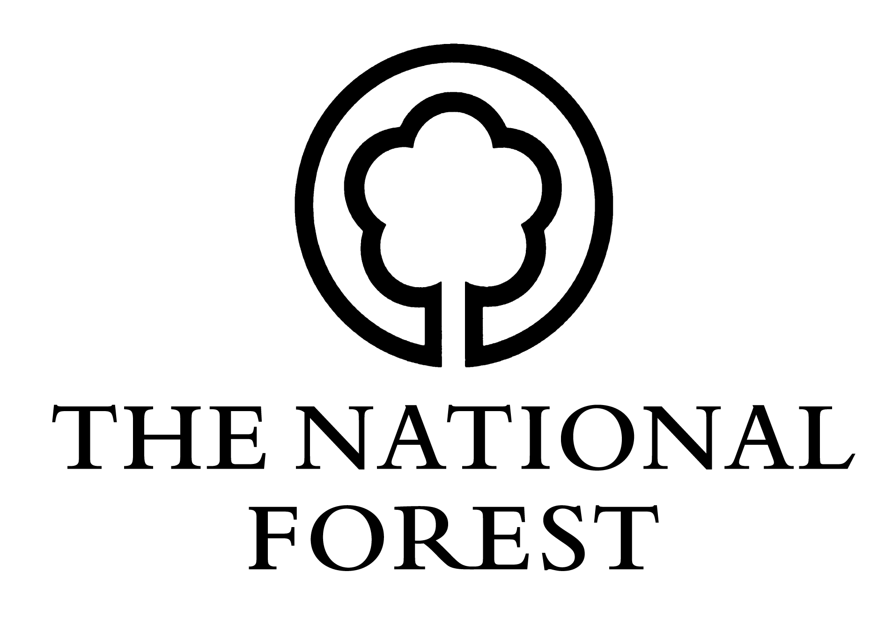
Changing Landscapes Scheme

Agent Fees Claim Form (NFCLS3)
Please return to: National Forest Company, Enterprise Glade, Bath Yard, Moira, Swadlincote, Derbyshire DE12 6BA. Telephone: 01283 551211 Email: grants@nationalforest.org
Scheme Name: |  | Official use only:
Scheme Number: |  | CLS No:
Size of Scheme: |  | Date Received:
Fee Amount: |  | Date of acceptance:
Name on Account:

Section 1: Managing Agent’s Details
Full name:
Organisation:
Address:
Postcode:

Section 2: Main Applicant Details:
Full name:
Address:
Postcode:

Section 3: Declaration
I am the owner/the lessee/the tenant named in the approved Contract as numbered above (delete as appropriate).
I certify that:
- the named agent was originally instructed to act behalf of the landowner/applicant.
- the design and application works have been carried out satisfactorily.
- the fee has been agreed by both parties.
Name: _______________________________________
Signed: _______________________________________
Date: ___/___/_____

