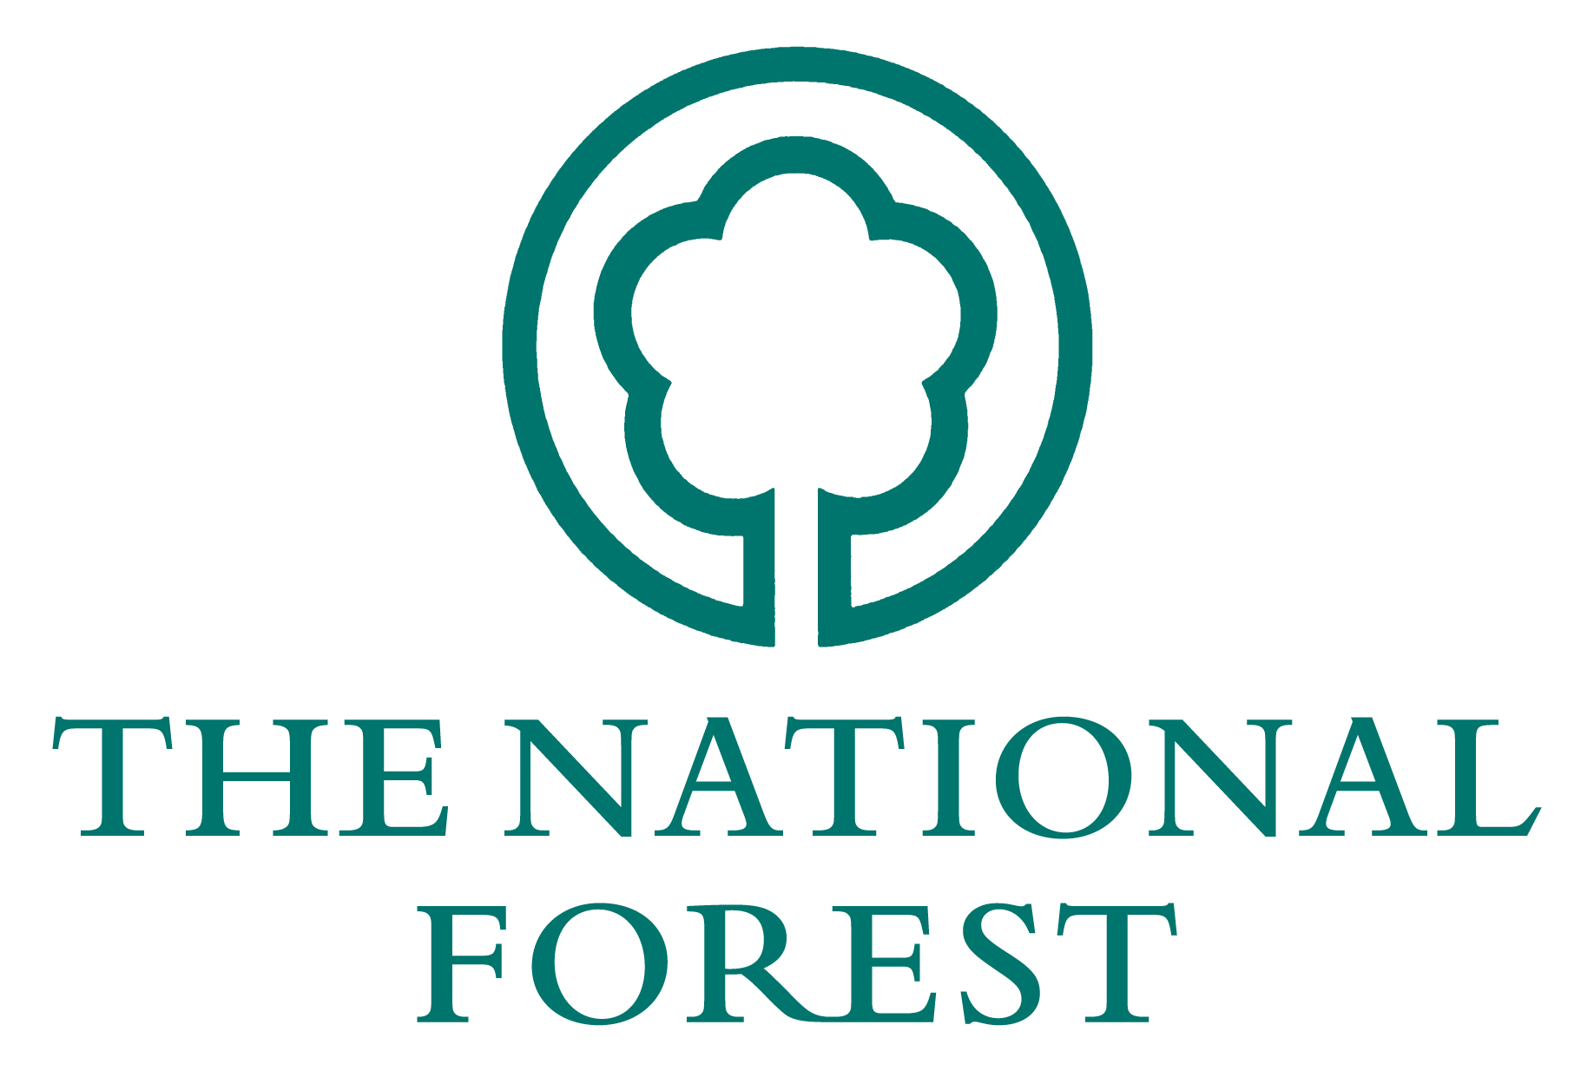National Forest Freewoods

Agents Fees Claim Form (NFFW3)

OFFICIAL USE ONLY

FW No. _______________________

Date Received _______________________

Date of Acceptance _____________________

Property Name _____________________________

Size of Scheme _____________________________

Fee Amount _____________________________

Name on Account ___________________________

1 Managing Agent's Details

Title __________ Forename _______________________ Surname _____________________________

Organisation / Business

Address
Postcode

2 Main Applicant's Details

Title __________ Forename _______________________ Surname _____________________________

Address
Postcode

3 DECLARATION

I am *the owner/ tenant/the lessee, named in the approved Contract. *delete as appropriate

I certify that:

a) the named agent was originally instructed to act on behalf of the landowner/applicant.

b) that the design and application works have been carried out satisfactorily

c) the fee has been agreed by both parties

NAME ___________________ SIGNED _______________________ DATE ___________

OFFICIAL USE ONLY:

