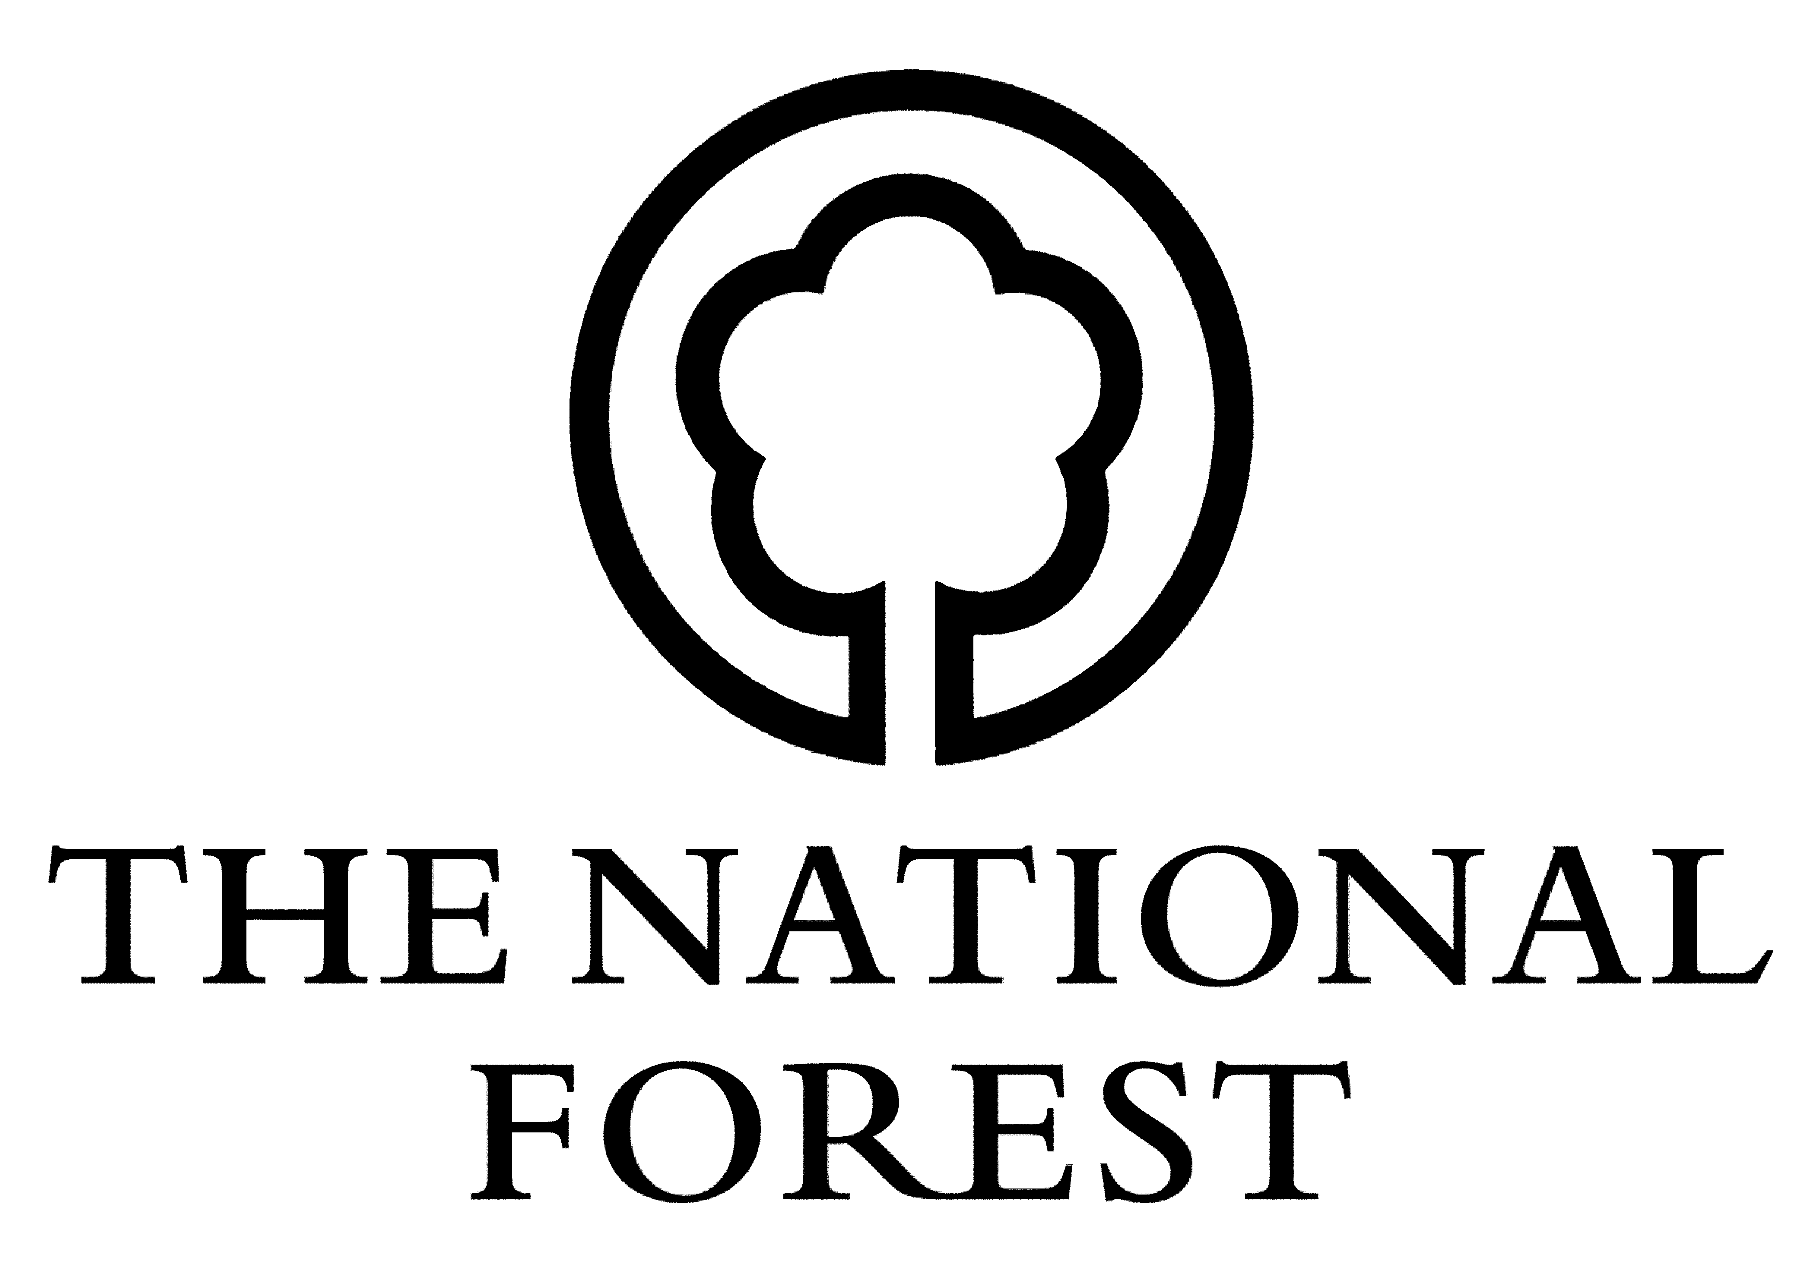National Forest Parkland Scheme

Claim Form

To be returned to the National Forest Company, Bath Yard, Moira, Swadlincote, Derbyshire, DE12 6BA. Tel: 01283 551211 Fax: 01283 552844 Web: www.nationalforest.org

AGENT DETAILS

1 TITLE ______ FORENAME _____________________ SURNAME _________________________

ADDRESS ____________________________________________________________________

____________________________________________________________________

_________________________________ POSTCODE _______________________

TEL NO _____________________ EMAIL _______________________

NAME ON CHEQUE ______________________________________________________________

2 PARKLAND REF _____________________________

SITE NAME _____________________________

3 DECLARATION I am the agent, named in the approved Contract as numbered above.

I certify that:

a) there has been no change of circumstances within the Contract.

b) planting and all associated works have been carried out in the area(s) described overleaf in accordance with the Contract.

SIGNED __________________________________________ DATE ___________________
4 Details of completed woodland planting work

Number of Parkland Tree Units completed in accordance with agreement:

------------------------------------------------------------------------------------------------------------------------------------------------------------------------------

5 Year 1 Claim

I hereby apply for payment of £ ____________ towards the actual costs of work identified in the schedule of works as identified in the Contract, which has been previously agreed with the National Forest Company.

If there have been any alterations to your schedule of works or payments beyond that agreed in your Contract, these must be approved by the National Forest Company before commencement of works.

SIGNED __________________________________________ DATE ___________________

For National Forest Company use - Signature of authorising officer

Parklands No _______________________ Claim Number _______________________

NFC £ ________________________ Signature ______________________________________

Total payment made £ _____________________________

National Forest Company, Bath Yard, Moira, Swadlincote, Derbyshire, DE12 6BA.

Tel: 01283 551211 Fax: 01283 552844 Web: www.nationalforest.org

