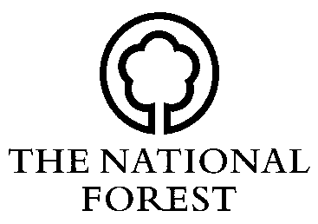
NATIONAL FOREST CHANGING LANDSCAPES SCHEME

CLAIM FORM (NFC CLS 2)

To be returned to the National Forest Company, Bath Yard, Moira, Swadlincote, Derbyshire, DE12 6BA. Tel: 01283 551211 email: forestry@nationalforest.org Web: www.nationalforest.org

1 TITLE ______ FORENAME _____________________ SURNAME ________________________

ADDRESS ____________________________________________________________________

____________________________________________________________________

_________________________________ POSTCODE _______________________

TEL NO _____________________ EMAIL _______________________

PAYMENT BY BACS (complete NFCBACS) /CHEQUE? (Delete as appropriate)

NAME ON CHEQUE/ACCOUNT _________________________

2 CLS NO. _____________________________

GRID REF _____________________________

SITE NAME _____________________________

3 DECLARATION I am *the owner/the lessee/the agent, named in the approved Contract as numbered above. *delete as appropriate

I certify that:

a) there has been no change of circumstances within the Contract.

b) planting or the work necessary to encourage natural regeneration has been carried out in the area(s) described overleaf in accordance with the Contract.

c) work has been carried out as detailed in the Contract and with due regard to the National Forest Strategy.

Note: Tender Scheme applicants claiming payments under the FWPS will need to complete a separate WGS 3 FWPS Claim Form. This is available from the NFC and FC or by download from www.forestry.gov.uk/forestry/infd-6kxfly

SIGNED __________________________________________ DATE ___________________
4 Details of completed woodland planting work

Name or number of management unit | Area of management unit in ha | Activity | Planting Year | Species | Area of Activity in ha

__________________ __________________ _________ ____________ __________ __________

__________________ __________________ _________ ____________ __________ __________

__________________ __________________ _________ ____________ __________ __________

Works other than planting: ________________________________________________________________

5 Interim Claims

I hereby apply for an interim payment of £ ____________ towards the actual costs of work identified in year _____________ of my schedule of works as identified in the Contract, which has been previously agreed with the National Forest Company.

Please note all claims for interim payments must be agreed in advance and in writing with the National Forest Company. If there have been any alterations to your schedule of works or payments beyond that agreed in your Contract, these must be approved by the National Forest Company before commencement of works.

SIGNED __________________________________________ DATE ___________________

6 Final Claims

I hereby declare I have carried out all works relating to Year ___________ of my Contract and claim

£ ______________, which has been previously agreed with the National Forest Company.

If there have been any alterations to your schedule of works or payments beyond that agreed in your Contract, these must be approved by the National Forest Company before commencement of works.

SIGNED __________________________________________ DATE ___________________

For Office Use Only

CLS No _______________________ Claim Number _______________________

NFC £ ________________________ Signature ______________________________________

Total payment made £ ___________________ Authorising Signature ___________________________

National Forest Company, Bath Yard, Moira, Swadlincote, Derbyshire, DE12 6BA

Tel: 01283 551211 Web: www.nationalforest.org
NFC Company Registration: 2991970 Registered Charity Number: 1166563

