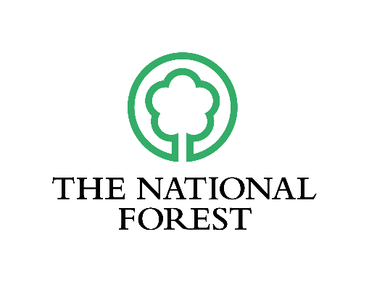
THE NATIONAL FOREST
CHANGING LANDSCAPES SCHEME
Guidance Notes 2022 (R15)

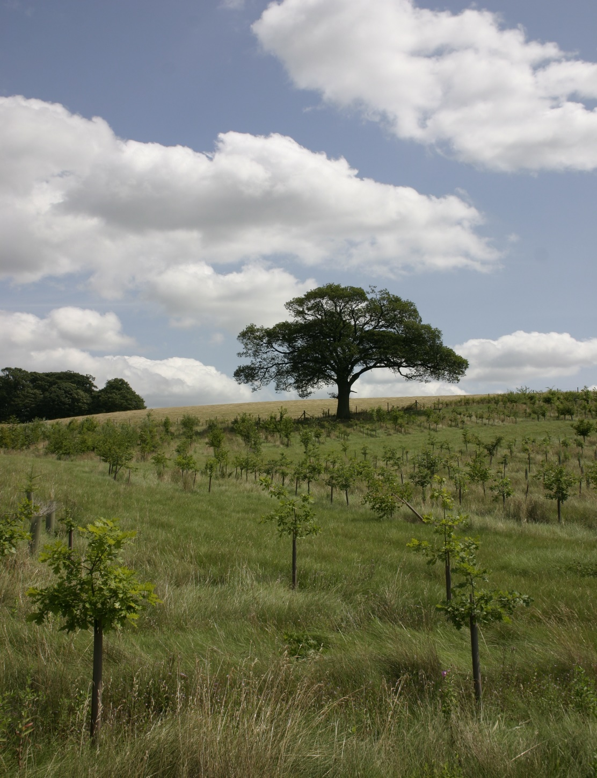

THE NATIONAL FOREST CHANGING LANDSCAPES SCHEME
Introduction

The National Forest Changing Landscapes Scheme is flexible and offers a generous level of funding to any landowner for the creation of new woodlands and associated habitats.

The Changing Landscapes Scheme (CLS) also funds habitat creation and management based on the Countryside Stewardship Scheme (CS) which is run by Defra and its agencies, but which, through the CLS, can be paid for outside this national grant regime. This means that, in addition to new woodland, which must be designed in accordance with Forestry Commission (FC) guidelines and meet the UK Forestry Standard (UKFS), land entered into the CLS may incorporate other habitats including parkland, wood pasture, meadows and unimproved grassland, orchards, hedgerows and wetlands.

The CLS requires competitive bids from landowners, with the elements of the schemes drawn from a standard and publicised working costs menu. For each item there is a prescribed maximum price which will be paid. A CLS application will be judged according to design and content and upon the overall contribution which it will make to National Forest objectives, (National Forest Strategy 2014 – 2024).

Please note schemes with reduced plastic impact will be viewed favourably, please consider replacing plastic guarding with other methods.

Eligibility

Any landowner with land in The National Forest may apply for the CLS and there are only a few restrictions on eligibility. These include: land which has previously been funded by the former National Forest Tender Scheme, the Woodland Grant Scheme (WGS), England WGS (EWGS); land which is under an existing Environmental Stewardship (ES) or Countryside Stewardship (CS) scheme; land which is required to be planted to satisfy a planning condition or to fulfil a Section 106 obligation. In addition, applicants will need to be registered on the Rural Land Register at the Rural Payments Agency to obtain a Single Business Identifier number. Further information on this can be found in the CLS Customer & Land Registration guidance leaflet from here.

Other restrictions include:

- Woodland intended for the production of Christmas trees or specifically woodfuel crops grown as short rotation forestry.
- Land that needs be planted to comply with a Felling Licence condition or Restocking Notice following conviction for an offence under the Felling Regulations of the Forestry Act 1967.

Scheme size

The minimum area of land for a CLS application is 1 hectare and there is no upper limit. All schemes must include at least 50% woodland creation (this can include up to 40% open land within the woodland component). Schemes can include multiple sites but in total must add up to a minimum of 1 hectare. Although it is not a requirement to enter CS, all new woodland must be designed and maintained in accordance with it and industry best practice. No planting must occur underneath overhead powerlines or within their proximity (minimum of 7 metres distance required either side of lines before shrubs or coppiced trees are planted). Land which is not planted must be managed in accordance with CS principles and must contribute to wider National Forest Strategy objectives. Where provision is being made for Biodiversity Action Plan (BAP) habitats and species related works, it is essential that they are appropriate and relevant to the location being considered.

The Process

The CLS is operated by the National Forest Company (NFC). The documents to submit are as follows:

- A CLS Round 15 application form (NFCLS1) including appendix 1 available from the NFC and as a download

- A Forestry commission Environmental Impact Assessment form, available as a download

- A spreadsheet of standard costs, available from the NFC and as a download

- CLS site design maps. These should be in colour, either A4 or A3 in size and include a scale, agent’s details and clients name, site location, hazards and constraints, pertinent design and landscape features, access points and routes where applicable, detailed planting arrangements, non-woodland components including nature conservation interests, and a key. Digitally produced maps are preferred.

- CLS woodland creation map. This will detail the area of woodland creation, including non-woodland elements funded under CLS. FC maps can be used in the production of site plans, here.

- Fire plan. The Local Authority Fire Services have the statutory responsibility for dealing with all uncontrolled fires, and therefore to ensure that adequate measures are taken for the prevention and suppression of fire, it is recommended that a fire plan is also produced for all woodlands. This plan is to include details of exact locations for access and water supplies and owner contact’s information: see guide.

- Where a proposal falls within the River Mease Catchment (http://environment.data.gov.uk/catchment-planning/OperationalCatchment/3303) the National Forest Company is required to undertake a Habitats Regulations Assessment (HRA) on the impact of the proposal. If your site is within the R Mease catchment, please advise Simon Greenhouse at NFC as soon as possible (ideally before submission of your bid).

Applicants should submit their bids on the application form at the time of making the application. Other than minor amendments resulting from consultation and assessment of
the scheme, the contract will be offered immediately following approval of a scheme and will be based upon the actual application that was submitted.

Schemes should normally be completed by the end of March in the planting season following approval. Successful applicants may be able to implement their schemes over two planting seasons, should this be necessary by agreement with the NFC. However the earlier that works are completed, the sooner a grant will be paid.

Successful CLS applicants will be required to enter into a 10 year contract. It is anticipated that most expenditure will be incurred in years 1-10. The first payment will be made in Year 1 on satisfactory completion of woodland and habitat works in accordance with the contract. This will comprise 80% of the total Year 1 to 10 costs (where schemes are implemented over two years, payments will be made pro-rata, based on the amount of work that has been completed).

The remaining 20% will be paid in Year 6, subject to annual inspections to ensure that maintenance and contractual requirements have been met.

For planting season 2022/2023 the CLS will open for Round 15 applications on the 1st October 2021 and close on the 7th January 2022.

Eligible works

The CLS is based upon a menu of standard costs for which grant aid is available, together with a specified maximum cost for each item (either on a one-off or annual basis). These cover all aspects of woodland and habitat creation and subsequent management. They have been based on the schedules used for Countryside Stewardship and previous national agri-environment grants but adjusted to reflect the particular requirements of The National Forest. The NFC undertakes an annual review of costs.

Schemes will not need to include all elements: the CLS is based on “Pick and Mix” according to landowner preference, location and land type. The NFC will assess applications carefully to ensure that no double counting or funding of ineligible works occurs.

The CLS menu of standard costs is available from the National Forest Company and as a download. CLS claim forms for works completed in Years 1 and 6 are also available from the web link; by using the NFCLS2 form.

Whereas the NFC requires professional input for scheme preparation, (see below) it does not specify who carries out the work nor does it require invoices. Payment is made on satisfactory completion of the works.

Tax

Grants, which cover the physical costs of woodland creation, are specifically exempt from liability to tax. In this respect all CLS applications which refer to the physical costs of woodland and nature conservation habitat creation would have no taxation liability.

Grant Levels

The level of grant will be different in each case. This depends upon the area of land involved, the features which are included and of course, the amount which is bid for. The NFC will place priority on the quality of the schemes submitted but in a competitive situation, the bid price against the gains provided will also be a factor.

Income Forgone Payments

Due to changes in EU regulations from 2014, we no longer offer income foregone payments to applications for new woodlands that are planted.

Woodland Creation

If it is discovered that the woodland has not been established or maintained as agreed or that the intended use of the land and the woodland has been changed without prior agreement, then the NFC may reclaim all the relevant grants paid and cease to pay further grants on the areas concerned. The woodland will be bound by the conditions set out in the Forestry Act 1967 and the UK Forestry Standard guidelines.

Tree Sourcing

Due to the increased prevalence of tree pests and diseases in the UK and the need for biosecurity, the NFC requires that all trees and shrubs procured through the Changing Landscape Scheme are UK sourced and UK grown from reputable British tree nurseries. The chain of custody must be verified by the chosen tree nursery/nurseries who supply the plants, with evidence provided as part of the grant claim to the NFC (i.e. suppliers documents).

Exceptions may arise where UK sourced and UK grown stock cannot be used for specific reasons (e.g. for certain commercial or specimen trees or where seed originating from abroad has been grown on in the UK). In such instances the NFC must be made aware prior to the trees being purchased, with reasons stated as to why UK stock cannot be used. The chain of custody for the plants must be similarly evidenced and verified for the grant claim.

The NFC reserves the right to not grant aid schemes that cannot provide the necessary tree sourcing chain of custody evidence.

Funding for scheme preparation

Applicants are required to seek professional help to design, implement and manage their schemes. The NFC will pay a fixed rate sum for scheme design and submission. This grant, which relates to the size of the scheme, is paid direct to the forestry consultant/designer by the NFC. The NFC has a list of consultants and contractors who have carried out work satisfactorily in the past in the Forest.

The NFC Board reserves the right to reject any schemes at the submission stage, should they be deemed substandard or inconsistent with the National Forest strategy. Where a lack of quality is pertinent, such schemes will have displayed a poor concept, failed the assessment process, or provided inadequate content in the application form with poorly presented maps and costings. In these circumstances no design costs will be re-reimbursed. Multiple applications from the same agent/landowner for any holding or piece of land in the same year are ineligible, even if the scheme has a number of sites.

In circumstances where otherwise good quality schemes have been submitted but prove to be damaging to existing nature conservation, archaeological or heritage sites, or deny public access without reasonable justification as set out in the CLS scoring assessment, schemes will be reimbursed for design costs but only after all attempts to overcome problems have run their course.

The design payment rates provided, based on scheme size, are maximum amounts and a breakdown of rates and time will be required on agent’s and advisor’s invoices. It is expected that typical schemes will come in at under the maximum rates. CLS claim forms for agents/consultant’s fees are also available from the web link by using the NFCLS3 form.
The maximum rates payable per scheme (+ VAT where applicable) are:

1- 5 Hectares £1,500
5-10 Hectares £2,000
> 10 Hectares £2,500

Signage

Detailed guidance regarding the content and style of signs and leaflets are available from the NFC and from the website.

Public Access

By virtue of the eligible works and costs associated with the provision and management of access, schemes with access will receive more funding. Unless there are justified reasons not to have public access, the scheme may be rejected. However, access provided through the CLS cannot be charged for.
Public access may take a number of forms: footpaths, horse-riding routes and cycle paths. Routes may be mown or surfaced. Access may be formal with dedicated routes (PROW, CROW dedicated areas) or more commonly it can be informal such as permissive access. Landowners may provide permissive access to all or part of their land and may restrict at specific times of the year, for example to protect ground nesting birds or for land management reasons. Access by arrangement for community use, educational visits and specialist use is permissible. Dedication of land under the Countryside and Rights of Way Act 2000 (CROW) is not required under the CLS.
Circumstances where access is not provided, but does not adversely affect the assessment of schemes may include:

- nature conservation and habitat creation
- reasonable privacy and security considerations
- public safety (e.g. next to roads, railways, waterways and hazardous industrial operations)
- the impracticability of reaching the woodland, due to its isolation, including location factors where there is no potential for connections to existing footpaths, bridleways and roadsides

NFC & FC Access to CLS Sites

The National Forest Company, Forestry Commission and their authorised agents’ staff maintain the right to visit and inspect CLS sites at any time, subject to reasonable notice. The applicant shall not reasonably restrict access to the CLS site without good cause. National Forest Company and Forestry Commission will undertake to visit all CLS bid sites to assess their individual merit, prior to approval. Visits to CLS sites will also take place by NFC following the completion of each year’s works and at years prior to the payment of the final instalment of grant aid.

Assessment

In addition to meeting the national requirements for woodland creation and habitat creation, set by FC and NE, the NFC will assess CLS applications according to criteria relating to The National Forest Strategy 2014-24 and Delivery Plan. These include:

- new woodland creation and enhancement of the landscape by the incorporation of open ground and other habitats
- landscape impact, based on location and/or the scale of new woodland involved
- the creation and management of wildlife habitats (especially related to the National Forest Biodiversity Action Plan)
- creating opportunities to link existing habitats
- the provision of access for the public, including walkers, cyclists and horse riders
- the provision of specialist access, for recreation, education and conservation use
- the protection or enhancement of existing conservation, heritage and archaeological
features
- the provision of opportunities for community involvement
- the provision of site signage, way markers and interpretation
- good silviculture practice and innovation
- the contribution to the development of the woodland economy
- consideration of and contribution to climate change issues

Landscape and design, nature conservation, public access and the scale and quality of design are weighted more strongly in scoring and assessment criteria.

Risk factors will also be considered relating to the need for planning or any other statutory permissions, a reliance on unconfirmed match funding, a requirement for landlord or co-owner agreement, past experience of woodland creation and certainty of securing land ownership by the contract date.

The NFC will operate a scoring system for these criteria, which will be set alongside the bid price to provide a value for money score, which will guide decisions on which schemes are successful, taking into account the competitive process. The NFC Board will ultimately decide the winning schemes and there may be instances where lower scoring schemes are selected, taking account of factors such as the overall funding available, location and the track record of the applicant. Details of the scoring system will be published by the NFC and made available in hard copy form and as a download from the website.

Appeals

Appeals against unsuccessful bids are not possible. A decision could only be successfully contested under judicial review if it was shown that the National Forest Company did not observe the rules of the CLS when reaching a decision on an application. Unsuccessful applicants will be encouraged to amend their applications and resubmit in a subsequent application. The NFC undertakes to provide feedback on the judging process to all unsuccessful applicants.

Commercial operations

The CLS cannot directly fund commercial operations, but it is possible for applicants to use the woodland and other habitats created through the scheme as a platform for diversification as part of a wider farm or business plan. There are considerable opportunities to obtain support for rural business development under the Rural Development Plan (RDP), administered by Defra for diversification, renewable energy, strengthening woodfuel supply chains, improving the economic value of existing woodlands and water resource management. Whilst double funding will not be permissible, where they wish to do so, applicants are encouraged to use the scheme as part of a wider approach to diversification and business development.

Further Information

Applicants should ensure their proposals fit with The National Forest Strategy 2014-2024

Nature conservation schemes should also specifically refer to the NFC’s Biodiversity Action Plan (3rd Edition, 2011). For further details of the Biodiversity Action Plan contact the National Forest Company.

Landscape schemes should refer to the landscape guidance here.

A bespoke publication that can help landowners consider the options for new farm woodland, “Create a Farm Woodland” is available in hard copy from the NFC or from the NFC’s website. This publication, referred to as a “toolkit”, was based upon experiences of landowners within The National Forest. The toolkit provides, in a concise and practical style,

information that can be used by all landowners who are considering creating new woods on farmland.

Summary

In summary, the National Forest’s Changing Landscape Scheme is a unique and well-funded measure which has been designed to encourage landowners of all kinds to continue the creation of The National Forest. As far as landowners are concerned, it retains many of the attractive features of earlier schemes, namely;

- landowners retain ownership and control of land

- the CLS can form part of wider, whole farm business plan and diversification proposal

- the woodlands and habitats created through the CLS can support wildlife, tourism, recreation and woodland economy businesses. Commercial operations cannot be funded by the NFCLS, but they can sit alongside land entered into the NFCLS

- landowners can deal directly with the National Forest Company and can expect the NFC to operate the CLS in a transparent and practical way, recognising landowner needs and, where appropriate, the farming calendar

In addition, the Changing Landscape Scheme can improve the carbon balance of the land holding and contribute to its long term value, for this generation and the next.

The National Forest Company
September 2021

For information about the Changing Landscapes Scheme and other woodland creation opportunities, please contact Simon Greenhouse using the details below:

Jon Lewney
Forest Creation Manager
01283 551211
cls@nationalforest.org

The Changing Landscape Scheme Application Process 2021/22

Opens January 2021 CLS Round 14 COMMISSION OF A PRIVATE AGENT / ADVISOR

LIAISON WITH LANDOWNER / NFC OVER SCHEME

CREATION OF SITE DESIGN MAP(S) / FIRE PLAN / WORK PLAN / TIMINGS & BUDGET COSTS

COMPLETE NFC CLS APPLICATION FORM & TABLE OF COSTS

Applications by May 2021 SUBMIT APPLICATION FORMS & MAPS (Site plan & woodland creation) AND ANY SUPPORTING DOCUMENTATION TO NFC PRIOR TO DEADLINE

NFC CARRY OUT CONSULTATION

NFC BOARD TO EVALUATE SCHEMES AND NFC TO NOTIFY RESULTS

CONTRACTS PRODUCED AND SIGNED FOR THE WINNING BIDS

IMPLEMENTATION OF WORKS

March 2022 PAYMENT FOR WORKS COMPLETED

Appendix 1 Supporting Notes for Completing the Woodland Creation Table (appended to CLS Application Form - NFCLS1)

Column 1 | Work Group  Use a letter to identify each work group. A Work Group is simply a convenient way of showing that all the detailed work elements (specification, rates, timing and claims etc) are all the same and can be applied to one or more sub-compartments. If parts of your woodland proposals are different in some way (eg different land use category, grant type, species mix, planting season and claim year) these should be separated out into different sub-compartments and entered under a different work group.
Column 2 | Current Land Use  Please insert the relevant code to tell us what the land us currently used for. All the sub-compartments in the Work Group must be the same.

Agricultural | Arable Land  Land previously eligible for the Arable Area Payments Scheme (AAPS) | AL
 | Other Cropped Land  Cropped land which was previously ineligible for the Arable Area Payments Scheme | CL
 | Improved Grassland | IG
 | Unimproved Land  Farmed land that does not qualify as arable land, or other cropped land, or improved grassland | UL
Non-agricultural | Industrial or Mineral  Land previously used for industry or mineral extraction | IM
 | Other Non-Agricultural Use  (eg horse gazing, public parks, school grounds | ON

Column 3 | Sub compartments in the Work Group  List all the sub-compartments that are in this Work Group. The total area of all sub compartments must have been entered in the table on page 2 of the CLS application form NFCLS1 (in the woodland creation categories) and they must be clearly shown on the application map(s).
Column 4 | Area of Work Group  Enter the total area of all sub-compartments included in their Work Group. The NFC will measure the areas from the maps but applicants should enter their estimate here.
Column 5 | Woodland to be Created  Enter the woodland category for this Work Group.  Woodland Categories  The following sets out the woodland categories with the characteristics and criteria that all planting must fall within. The prescription for each afforested area or defined part of the area (compartment or sub-compartment) must fully fit within a particular category in order for it to benefit from the spacing, shrub and open ground allowances designated for that category. The default categories are Standard or Small Standard.  Woodland Category Characteristics Stems/ net ha required at estab’t Spacing Grant-aided open ground (% of grant-aided area) Grant-aided shrub element (% of grant-aided area)  Standard Wood size is 3.0 ha or more and not one of the other types 2250 Max 2.5m Up to 20% where fully justified Max 10%  Small Standard Wood size up to 2.99 ha and not one of the other types 1100 Max 3.0m Normally 10%. Up to 20% where fully justified Max 15%  Native* Native species only and an agreed and appropriate native woodland type for the site and location. Planting as per FC Bulletin 112 'Creating New Native Woodland' 1600 (or as required to create habitats for BAP priority species) Max 15m Up to 40% where fully justified Max 25%  Community Designed for public access and is agreed as an appropriate woodland type for the location As agreed with NFC. Between 1100 and 2250 Max 3.0 m Up to 40% where fully justified Max 25%  Special Broadleaf Appropriate single species broadleaved trees grown at wide spacing As agreed Minimum 100 Max 10m Normally 10%. Up to 20% where fully justified 0% Shrubs may be planted as additional plants but will not be eligible for grant
 | * If Native woodland is to be created, also enter the National Vegetation Classification type that best represents the type of native woodland proposed. The NVC type proposed will need to match the drainage of the site, the pH of the soil, the climate and the species range and mix.
Column 6 | Species Mix  Enter the species to be used for his Work Group and the estimated percentages of the total Work Group area for each. Use separate lines for:  - Each tree species that will comprise 20% or more of the woodland. Other species can be grouped together using the Species group codes for this purpose. Where Species Group codes are used, list the species included in this mix in Column 10 of the table  - Woody Shrubs (WSH)  - Open ground (OG) which is to be part of the woodland creation area.

 | Species Group - Species code for entry into Column 7
 | Species Code | Species Code | Species Code
 | Native Mixed NBL  Broadleaves | Native Mixed MB  Broadleaves | Other broadleaves XB  not in the main list
 |  | Mixed Conifers MC | Other conifers XC  not in the main list

Other Elements
Species Code | Description
Woody Shrubs WSH | Native woody shrubs and minor trees appropriate to the site, ie. hawthorn, blackthorn, holly, dogwood, alder, buckthorn, purging buckthorn, spindle, guelder-rose, wild privet, elder.
Open Ground OG | Managed open space (note the limits on OG for each woodland category).

Broadleaf Species (*=native)
Species Code | Species Code | Species Code
Alder * AR | Elm * EM | Red Oak ROK
Common Alder * CAR | Hazel * HAZ | Poplar PO
Grey Alder GAR | Hornbeam * HBM | Rowan * ROW
Aspen * ASP | Lime LI | Sweet Chestnut SC
Birch BI | Small-leaved Lime * SLI | Sycamore SY
Downy Birch * PBI | Field Maple * FM | Willow * WL
Silver Birch * SBI | Norway Maple NOM | Goat Willow * GWL
Wild Cherry * WCH | Pedunculate Oak * POK | Cricket Bat Willow CBW
Beech BE | Sessile Oak * SOK
Conifer Species
Species Code | Species Code | Species Code
Western Red Cedar RC | European Larch EL | Scots Pine SP
Lawson Cypress LC | Hybrid Larch HL | Norway Spruce NS
Douglas Fir DF | Japanese Larch JL | Sitka Spruce SS
Grand Fir GF | Corsican Pine CP | Western Hemlock WH
Noble Fir NF | Lodgepole Pine LP | Yew YEW

NB Larch only east of M/A42, (risk zone 3 http://www.forestry.gov.uk/pdf/Pramorum_risk_zones_Oct11.pdf/$FILE/Pramorum_risk_zones_Oct11.pdf ),
Corsican Pine is no longer recommended due to risk of Dothistroma Needle Blight (http://www.forestry.gov.uk/forestry/INFD-7L6E57#6.3 )
Ash is not currently available for planting due to ash dieback (Hymenoscyphus fraxineus)

Column 7  Column 8 | Percentage to be established by natural regeneration  If it is intended to encourage and include naturally seeded trees as some part of the established woodland, estimate the proportion of the Work Group area to be established in this way. This information ensures that any later inspection can take these additional trees into account.  Planting Season  Specify the planting season in which you will carry out the work.
Column 9 | Additional Details  Use this column to note any changes to the Standard Proposals used and to make clear any particular details that help describe the work accurately. Such details might include:  - List of species included in Species Group codes (eg. MB or WSH)  - A description of how the species will be distributed across the site  - The proposed ground preparation for natural or direct seeding of trees  - Details of public access provisions (eg. path maintenance, access points, signage etc)  Applicants may also set out their own work specifications in this column rather than nominate standard specifications but these must include sufficient information to accurately describe the work details.  General details on woodland description and additional information can also be entered.

