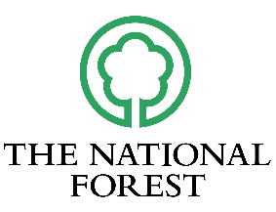
The National Forest Company
Volunteer Registration Form
Thank you for completing this form and offering your time and skills to support the National Forest.
All information will be treated as confidential and not passed to any other organisation without prior consent. For our full privacy policy, please see https://www.nationalforest.org/privacy-policy
Part 1: About you
Name:
Address:
Postcode:
Telephone no:
Email address:
☐ I confirm that I am over 18.
Part 2: Your interest in volunteering

What motivates you to volunteer?
☐ Build confidence
☐ Develop new skills
☐ Exercise / to stay active
☐ Socialising / networking
☐ Support wildlife conservation
☐ Other (please state):
______________________
What volunteering activities are you interested in?
☐ Conservation tasks
☐ Habitat creation
☐ Looking after community areas
☐ Species monitoring
☐ Woodland management
☐ Other (please state):
______________________
Where did you first hear about this opportunity?
☐ National Forest Website
☐ Poster / flyer
☐ Social media (please state):
______________________
☐ Word of mouth
☐ Newsletter
☐ Other (please state):
______________________
Part 3: Emergency details and medical information
Do you have any medical conditions or allergies which you would like to make us aware of?

☐ Yes (please specify):
☐ No
__________________________________________
Do you require any support or adjustments to volunteer with us? If yes, a member of our team will contact you directly to discuss these further and find out how we can best support you.
☐ Yes
☐ No
Emergency contact details:
Name
Relationship to you
Contact number

