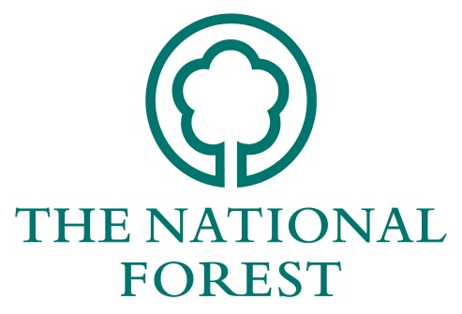
NATIONAL FOREST COMPANY

WOODLAND ECONOMY GRANT

APPLICATION FORM 2019/20

Please complete the form fully, using additional sheets where necessary.
Name:
Organisation:
Address:
Agents details:
(if applicable)
e-mail: |  | Telephone:
Are you registered for VAT? ☐ Yes ☐ No

If applying on behalf of an organisation please describe the organisation’s aims and financial structure. The National Forest Company may also require a copy of their audited accounts.

Details of Proposals
Please tick which of the following objectives your project will contribute to. Further information on the objectives can be found in the Woodland Economy Grant Guidance Notes.
☐ Harvesting Equipment | ☐ Training
☐ Processing Equipment | ☐ Feasibility study
☐ Marketing / Business Development | ☐ Haulage Equipment
☐ Other Please detail …………………………………………………………………………………………………………………

Please describe what you are seeking grant funding for and how it will deliver the objectives identified above.
Estimated start date: |  | Estimated finish date:

Please identify the specific benefits of your project and how you will measure the outcomes.

Specifications & Costs

Expected Total Cost
Please provide an outline of the expected cost for the item(s) that grant funding is being applied for. Please complete and submit the separate WEG costs calculator form to detail all costs identified. Note If successful you will be required to provide the NFC with 2 quotes for all items with reasoning provided on why the successful quote was chosen.

Applicants Resources (Match funding)
Please say where the remaining funds will come from, including grants requested or obtained from other organisations. Include in-kind contributions (as appropriate and eligible). Match funding with other public forestry/woodland grants (e.g. Forestry Commission) cannot be accepted.
Have you received NFC funding through previous grant funding? Yes ☐ No ☐
If yes, please provide the NFC reference number(s) and reasons why continued funding is required:
Applicant's legal interest in the business (e.g. owner, director, employee).

Does any element of the project require planning permission or any other form  of statutory consent (e.g. Shed construction)?  If yes, has this been approved? (please attach any approvals) | ☐  ☐ | ☐  ☐
(Please note: If you do not answer these questions, your application may not be proceed)

Additional information in support of the proposal. (All works must be undertaken with any relevant permissions)

Declaration
I have read and accept the attached ‘Conditions of Grant Aid’. To the best of my knowledge the information supplied with this application is correct.
Signed:
Name:
Date:
Please list any enclosures sent with this application.
1:
2:
3:
4:
5:

Checklist
Have you given all the information required (your application may be rejected without these components)?
☐ | Signature and date | ☐ | Relevant business plan (if applicable)
☐ | Details of match/other funding | ☐ | A breakdown of specifications and costs
☐ | Project objectives and timetable

Please return the completed form to: Dave Garner
The National Forest Company
Bath Yard
Moira
Swadlincote
Derbyshire DE12 6BA

Or by email to dgarner@nationalforest.org

If you have any queries about the application process that are not answered by the Woodland Economy Grant Guidance notes, please contact Dave Garner on 01283 554211

