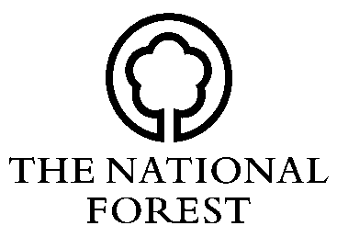
NATIONAL FOREST SCHEMES

BACS DETAILS FORM (NFC BACS)

Contact Details
Title |  | Forename
 |  | Surname

Address
Postcode |  | Email
Telephone Number |  | Scheme Reference

Bank Details

Bank Name

Account Name

Account No.

Sort Code

DECLARATION I am *the owner/the lessee/the agent, named in the approved Contract as numbered above.*delete as appropriate
 | Signed | Position | Date

To be returned to: National Forest Company, Bath Yard, Moira, Swadlincote, Derbyshire, DE12 6BA.

Tel: 01283 551211 Fax: 01283 552844 Web: www.nationalforest.org

