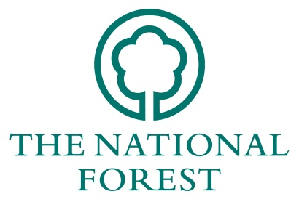
National Forest Company
Woodland Economy Grants 2019/20

Guidance note for applicants

This note provides guidance on how to apply for a National Forest Company (NFC) Woodland Economy Grant (WEG). Please note only projects which directly benefit the National Forest are eligible for assistance.

1. What sort of projects are eligible?
WEG eligible projects must demonstrate clear benefits for at least two National Forest objectives including:
- The National Forest Strategy
- Increasing harvesting volumes and/or efficiency
- Growing the woodland economy
- Woodland business development
- Marketing woodland products
- Customer management and communication
Many projects have the opportunity to provide multiple benefits. Clear links should be demonstrated to meet the National Forest’s objectives.
Grants will be competitive, to ensure that the most beneficial applications receive funding. The applications will be scored (using the Woodland Economy Grant Scoring Criteria) by the National Forest Company to assess the applications that provide the greatest benefits.
Table 1 (at the end of these notes) lists the types of projects that can be grant aided. Investments which combine a number of elements are particularly encouraged.

2. Who can apply for a Woodland Economy Grant?
Grants are available for businesses and organisations involved in harvesting, processing and sale of wood within the National Forest.
Government bodies and agencies (such as the Forestry Commission and Natural England) are not eligible to apply for these grants.

3. Grants criteria and eligibility
Grants are available to fund up to 50% of the total project cost. New applications may be made for additional stages of a project, if appropriate. However, this should be discussed with the NFC at the time of the initial application.
NFC will pay up to a maximum of £10,000 (inclusive of VAT), towards works at any one project within a financial year (1st April – 31st March). The NFC reserves the right to alter this figure throughout the year depending on grant uptake and budget availability.
To help applicants raise their share of the total cost of projects, match-funding may include cash funds raised or donated and grants received from Local Authorities or other grant-making bodies. If match-funding is dependent upon receiving grants from other sources this could result in the NFC grant payment being delayed pending confirmation of that other award, bear this in mind if you want to avoid delays.
A business plan or similar must be in place, or in late development before successful grant application. A copy of the business plan must be supplied to the NFC at the second stage, the detailed grant application.
The NFC will not fund projects where other more suitable sources of funding have not been applied for first (for example Countryside Stewardship). In addition the WEG cannot be used in the following circumstances:
- activities that do not lead to a volume or value increase for woodland products.
- to double fund works that are already funded through other NFC or publicly funded grant schemes (e.g. Forestry Commission, Environmental Stewardship, England Rural Development Programme).
- for the acquisition of land or buildings; works required as part of any planning agreement; or ‘capital’ items such as vehicles and computers. Consideration will be given for the hire of such items, if relevant.
- core-funding expenses such as staff wages, rents or on-going maintenance costs.

4. How to apply for a Woodland Economy Grant
The application process and timeline for the WEG is provided in Figure 1 below. Submissions must be made on the application form provided and available on the NFC’s website www.nationalforest.org. It is advisable that, before completion, potential applicants discuss their projects with the appropriate member of the NFC team to ensure eligibility for funding.

The contact for the WEG is: Dave Garner 01283 551211 or dgarner@nationalforest.org

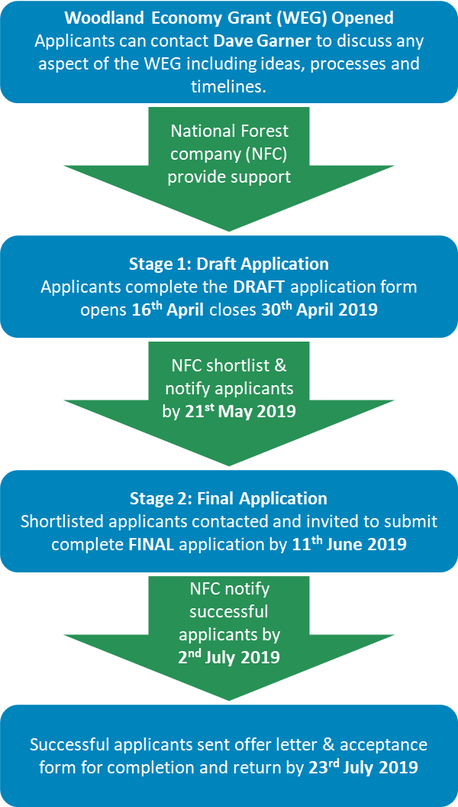
Figure 1: Woodland Economy Grant process timeline
Projects will need to be completed and claims processed for payment before 31st January 2020.

5. Guidance on completing the application form
The following guidance will help ensure that you provide all of the correct information needed by the NFC to process your application. Please read it carefully as missing or incorrect information may delay processing.
Applicant details
This information will be used for all correspondence. Where possible, the NFC will use email to respond to your application so it is important that (if available) a correct email address is included.
In describing your organisations’ aims and financial structure, a simple summary is all that is required. The NFC retains the right to request a copy of your audited accounts, but will ordinarily only request this in certain circumstances.
Details of proposals
It is essential that you identify the objectives of your project and how these contribute towards achieving the objectives of the National Forest Strategy. Use Table 1 at the end of these notes to help you. When describing your project, make sure to reference how it will deliver the objectives that you have highlighted.
It is also important to be clear about the timetable for the project. The WEG must be applied for, spent and claimed within the same financial year. Where projects run across financial years, you should discuss this with a member of the NFC team to ensure that this will not present problems.
When considering the benefits of your project to The National Forest, be sure to consider wider as well as direct benefits. For example, the creation of a website may have benefits in client management, as well as new sales, brand awareness and educating clients about The National Forest.
Specifications and costs
The full costs of the project should be provided in the application. The grant requested cannot be more than 50% of the total cost of the project, so it is essential that you identify all costs or it may reduce the amount of grant you are able to receive.
Under ‘Applicants Resources’, you must be able to provide 50% of the total project costs. If different match-funding elements are involved, they should each be described and the amounts given. If grants from other organisations are to be used as match-funding, you should clearly state whether this funding has been secured or, if not, when it is expected.
The WEG costs calculator must be complete for all applications detailing all investments being applied for. Two competitive quotes must be provided. These must be comparable in what they are quoting for.
Infrastructure/Building proposals
Where your project involves the use of land, you must provide the information requested. This will allow the NFC to ensure that there are no potential conflicts with existing land uses. Please provide a six figure grid reference for the site (e.g. SK 123 456) as part of the description of its location.
It is important that you specify your legal interests in the site and where you do not own the site, the details of the landowner. This is necessary to ensure that the landowner permits the proposed work on their property. If you withhold any relevant information regarding land ownership, the NFC retains the right not to offer any grant.
Declaration
Finally, the Business owner or organisation lead must sign the declaration on page 3 and provide the other information requested.
The NFC must receive a signed copy of the application to be able to process it. If emailing a copy of the application form, a signed paper copy must also be sent via post (or scanned and e-mailed).
Completed application forms should be returned to: Dave Garner, Woodland Management Officer at:
The National Forest Company, Bath Yard, Moira, Swadlincote, Derbyshire, DE12 6BA, or to dgarner@nationalforest.org.

6. What happens next?
The WEG fund has limited resources, which must be apportioned to strategically provide support to projects throughout the whole of The National Forest. Applications will be scored on their merits and value for money in delivering the National Forest Strategy. In determining whether to offer a grant, the WEG Scoring Criteria will be used to guide the decisions of the National Forest Company. The National Forest Company has sole discretion as to whether to offer grants or not.
If successful, you will be sent an offer letter detailing the amount offered, the conditions of the grant offer and the date by which the grant must be claimed. We will then require written confirmation of your acceptance of the grant on the “Acceptance of Grant Aid” form sent to you with the offer letter.
The applicant will be required to provide evidence of the benefit of the NFC investment 12 months after receipt of funds. This can be through proof of volume or value increase of output material or evidence of training and marketing improvements or similar evidence for other investments.

7. Submitting your claim
Ordinarily, claims can only be made on completion of the project. When claiming your grant, it is important that you use the claim form sent to you with your offer letter. If you cannot locate the claim form, you can ask for a replacement copy from the NFC, or download from the website.
Payment will be made by cheque or BACS transfer, so you must specify the name to which a cheque should be made payable, or complete a BACS payment form at the time of the claim.
Proof of payment must be provided for any items outside of the standard costs (e.g. training & other projects).
When providing a breakdown of the expenditure claimed, it is important that you provide a full breakdown of the total final costs of the project. It is this figure that will determine the amount that you can claim. Unless otherwise stated in the offer letter, the amount claimed cannot be more than the amount offered or up to 50% of the final total cost of the project (whichever is less).
In special circumstances, grants can be claimed in a number of payments (based on agreed outputs/milestones). In these cases, the amounts of previous claims against the current grant should be provided.
Unless agreed with the NFC, claims must be submitted by the deadline specified in your offer letter. This should take the form of a full account of your project’s income and expenditure as well as information on the work done. Photographs, taken before, during and after the project should also be included.

If you have questions about any aspect of the Woodland Economy Grants, please contact
Dave Garner at the National Forest Company on 01283 551211.
Table 1
NFC Woodland Economy Grants

Activity | Key objectives | Examples
Increased or improved harvesting | - increase in the volume of wood being harvested  - increase in the value of the wood harvested | - Machinery to increase the speed with which the workforce can harvest timber e.g. shears, chainsaws, harvesters  - Machinery that allows a greater percentage of the tree to be used and sold e.g. wood chipper for brash  - Training to improve operator efficiency
Increased or improved processing | - Increased volume throughput of the business/organisation  - Improved quality of the material processed by the business/organisation  - Increased value of the material processed by the business/organisation | - Loading equipment that facilitates management of wood creating greater processing efficiency e.g loading deck for a processor, bagging equipment  - Wood chipping machinery that allows the processing of previously unused material and offcuts  - Saw dust capture equipment allowing sale of product  - Wood processing equipment that provides improved quality in size and length of logs e.g. a log processor  - Processing equipment that creates a higher value material for sale e.g. charcoal retort  - Quality control equipment e.g. moisture meter for quality control  - Training to improve operator output
Marketing/Business Development | - Increase in market awareness of your product(s) and brand  - Improved client management and service delivery  - Expert support in the creation of a business strategy | - New website/website upgrade delivering customers with clear information about your business, services and products  - Business management training for key personnel to help deliver key strategic growth  - Information boards marketing your products and the benefits that they provide to The National Forest. E.g. an A board for when you’re doing woodland works that clearly identifies the benefit of 1st thinning to biodiversity and tree growth while creating a local sustainable product.  - Expert support in the completion of a business strategy to deliver a clear plan for the business
Training | - Improved efficiency of business operatives  - Improved safety of operations | - Equipment training for operatives using tools such as chainsaws, shears and harvesters.  - Health and safety training for forestry or specific operations  - Training for business management team to improve skills
Feasibility Study | - To ensure that investment is made into viable technology | - Assessment for the installation of a biomass heating system  - Assessment of the potential for district heating  - Review of the potential for investing in new equipment to create a new product such as thermally treated wood
Haulage Equipment | - To improve efficiency in the supply chain for businesses | - Purchasing of a forwarder to enable improved cost effectiveness of harvesting operations

