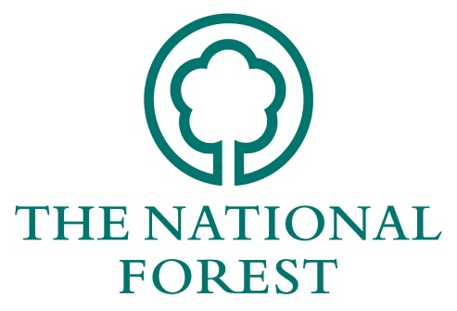
NATIONAL FOREST COMPANY

WOODLAND MANAGEMENT GRANTS

APPLICATION FORM 2018/19

Please complete the form fully, using additional sheets where necessary.
Name:
Organisation:
Address:

Agents details:
(if applicable)
e-mail: |  | Telephone:
Are you registered for VAT? ☐ Yes ☐ No

If applying on behalf of an organisation please describe the organisation’s aims and financial structure. The National Forest Company may also require a copy of their audited accounts.

Details of Proposals
Objectives: Please tick which of the following objectives your project will contribute to. Further information on the objectives can be found in the Woodland Management Grants Guidance Notes.
☐ Woodland management planning | ☐ Controlling wildlife
☐ Woodland management works | ☐ Public access works
☐ Woodland infrastructure | ☐ Community engagement
☐ Woodland management training | ☐ Demonstration projects
☐ Non wooded habitat | ☐ Works relating to tree health issues

Proposals: Describe your project and how it will deliver the activities you have ticked above. Please indicate the aims of the project, its timetable and how it will be delivered.
Estimated start date: |  | Estimated finish date:

Benefits: Please indicate the specific benefits of your project to The National Forest and how you will measure its outcomes.

Specifications & Costs
Has the costs calculator been fully completed and attached? Yes ☐  No ☐

Applicants Resources (Match funding)
Please say where the remaining funds will come from, including grants requested or obtained from other organisations. Include in-kind contributions (as appropriate and eligible). Match funding with other public forestry/woodland grants (e.g. Forestry Commission) cannot be accepted.
Have you previously applied for Countryside Stewardship? Yes ☐  No ☐
Please explain why this funding is not applicable to your site:
For continuing long-term activities, please indicate how the activity is intended to be funded when National Forest grant-aid finishes.

Site Management Proposals
If you are applying for a grant towards the management or development of a site, please indicate whether you have a separate management plan or the equivalent for the site.
Name of site:
Location:
Grid Reference:
Area in hectares:
Management Plan: | ☐ Yes | ☐ No | If Yes, please attach a copy with your application form.
(Please note a site management plan must be in place or in production to be eligible for funding)
Has the site been funded by the NFC through previous grant funding? Yes ☐  No ☐
If yes, please provide the NFC reference number(s) and reasons why continued funding is required:
Applicant's legal interest in site (e.g. freehold, leasehold, agreement).
Note: If Leasehold or agreement, give details.

If the site is not owned by the applicant, please provide the owner's name and address.

Is the site: |  |  | Yes | No
 | A designated site for wildlife (e.g. SSSI, LNR, local wildlife site)?  Details: ………………………………………………………………………………………….. |  | ☐ | ☐
 | A designated/listed site for historic or archaeological interest?  Details:………………………………………………………………………………………….. |  | ☐ | ☐
 | Designated with a Tree Preservation Order?  Details:………………………………………………………………………………………….. |  | ☐ | ☐
 | Included in any forestry or agri-environment schemes  (e.g. Countryside Stewardship)  Details:………………………………………………………………………………………….. |  | ☐ | ☐
 | Other? Please describe: |  | ☐ | ☐
Does any element of the project require planning permission or any other form  of statutory consent (e.g. drainage)?  If yes, has this been approved? (please attach any approvals)  Do any of the proposed works require a felling license from the Forestry Commission?  If yes, has this been approved? (please attach any approvals) |  |  | ☐  ☐  ☐  ☐ | ☐  ☐  ☐  ☐
(Please note: If you do not answer these questions, your application may not be proceed)
Additional information in support of the proposal. (All works must be undertaken with any relevant permissions, be compliant with European Protected Species legislation and UKFS guidelines)

Declaration
I have read and accept the attached ‘Conditions of Grant Aid’. To the best of my knowledge the information supplied with this application is correct.
Signed:
Name:
Date:
Please list any enclosures sent with this application.
1:
2:
3:
4:
5:
6:

Checklist
Have you given all the information required (your application may be rejected without these components)?
☐ | Signature and date
☐ | Details of match/other funding
☐ | Development and/or management plan (if applicable)
☐ | Project objectives and timetable
☐ | Site details (including information on designations or agri-environment schemes if applicable)
☐ | A breakdown of specifications and costs
☐ | Relevant maps and plans
☐ | Completed Costs Calculator
☐ | Pre site work photographs

Please return the completed form to:

The National Forest Company
Bath Yard
Moira
Swadlincote
Derbyshire DE12 6BA

Or dsmall@nationalforest.org
If you have any queries about the application process that are not answered by the Woodland Management Grant Guidance notes, please contact Daniel Small on 01283 551211

