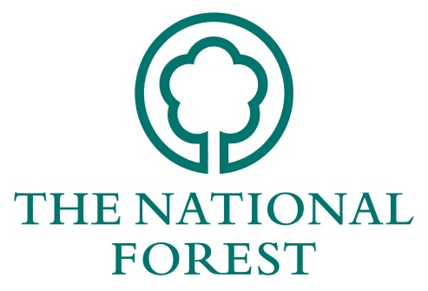
NATIONAL FOREST COMPANY

WOODLAND MANAGEMENT AWARD

APPLICATION FORM 2019

Please complete the form fully, using additional sheets where necessary.
Name:
Organisation:
Address:

Agents details:
(if applicable)
e-mail: |  | Telephone:
Name of site:
Location:
Grid Reference:
Area in hectares:
I am applying for the following category (you will need a separate application for each category):
NFC Silva Award ☐
Woodlands showing exemplary silvicultural management, including; developing high timber quality, producing climate resilience, protecting from pest and disease, use of innovative forestry practises and marketing of produce.
NFC Wildlife Award ☐
Woodlands showing excellent wildlife management, including; creating valuable habitats, encouraging important flora/fauna, innovative management techniques, and installing well thought out wildlife infrastructure.
NFC Forest for the People Award ☐
Woodlands exhibiting superb access and connectivity for people, including; accessible routes for wide range of users, clear and informative interpretation, collaborative working with the community/volunteers and the enhancement of any historic features on the site.
Forest of the Year
All applicants will be accessed for the Forest of the Year award, which will reward an outstanding project which has excelled in a wide range of criteria.

500 Word Statement
A statement of about 500 words should be supplied, starting with the objectives of management. It should give details of the exemplary management of the woodland for productive timber, wildlife/biodiversity and people. Details should include; site vision, objectives, methods used, successes and learnings.

Declaration
I am submitting this application to the National Forest Woodland Management Award 2019. To the best of my knowledge the information supplied with this application is correct.
Signed:
Name:
Date:

Please list any enclosures sent with this application (supporting info eg maps, photos).
1:
2:
3:
4:
5:

Please return the completed form by 5pm on Friday 16th September to:

The National Forest Company
Bath Yard
Moira
Swadlincote
Derbyshire DE12 6BA

dsmall@nationalforest.org or dgarner@nationalforest.org

